Project #1
STAT 875
Spring 2015

Complete the following problems below. Within each part, include your R program output with code inside of it and any additional information needed to explain your answer. Your R code and output should be formatted in the exact same manner as in the lecture notes.

- (11 points) Exercise #3 parts (a)-(c). Use α = 0.05 for part (b). For extra credit, perform the same experiment yourself with Milk Chocolate Hershey’s Kisses. Complete part (b) for your data. To prove you actually did the experiment, provide a YouTube link to a video of you performing the experiment! Note that the web address for the cited paper in the problem is http://www.amstat.org/publications/jse/v10n3/haller.html.

- (12 points) Exercise #13. Do not use binom.plot() to complete the exercise. Hint: The true confidence level at π = 0.157 is 0.9448. I recommend verifying you can obtain this value first BEFORE calculating ALL of the true confidence levels in part (b)!

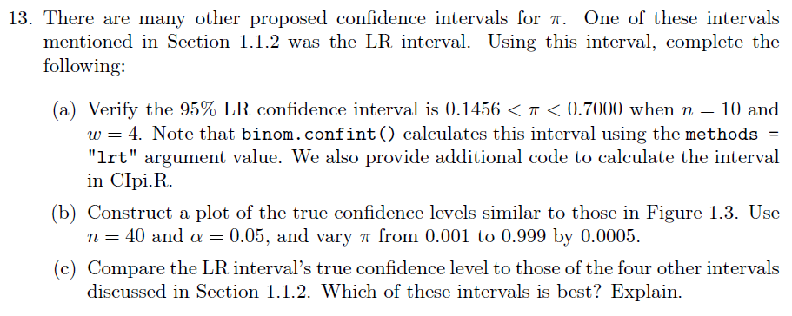

- (18 points) Olestra is a fat substitute that was first used in the late 1990s. It is not used very often now due to gastrointestinal side effects that some people reported after consumption of food with Olestra. The paper

Cheskin, L., Miday, R., Zorich, N. and Filloon, T. (1998). Gastrointestinal symptoms following consumption of Olestra or regular triglyceride potato chips: A controlled comparison. Journal of the American Medical Association 279(2), 150-152.

examined a controlled experiment to determine if side effects truly occurred. Below is a 2×2 contingency table summarizing some of their results:

 | Side effects | No side effects
Olestra | 89 | 474
Regular | 93 | 436

Using this data, complete the following:
  - (3 points) Examine the paper. Describe the sample used for the study and the intended population. What assumptions are needed to make this sample representative of the intended population?
  - (9 points) Will Olestra cause side effects for people in the population? Use a Pearson chi-square test for independence, a relative risk, and an odds ratio to answer this question. While normally only one of these would be needed in practice, I want you to examine all three so that I can assess your understanding of these measures. Make sure to FULLY interpret all results! This includes making a statement such as “The odds of a …” and “The probability of a … ” as shown in the notes.
  - (3 points) Answer the question below that corresponds to your answer from part b):
    - Olestra cause side effects: Would you recommend that people eat food with Olestra? Explain.
    - There is not sufficient evidence that Olestra cause side effects: The introduction of the problem said that Olestra is not often used in foods now due to side effects that some people reported. What could be a STATISTICAL reason for why your conclusion is not the same?
  - (3 points) The news media will often report on results from medical research when it is first published. Suppose this paper on Olestra was just published. Write a one-paragraph report about the study that is at a level appropriate for the Lincoln Journal-Star. Note that this means that you cannot assume someone has had any statistics courses! Focus only on the data analyzed for this problem.

