Test #2
STAT 494/873
Fall 2025

Complete the problems below. Use R for all calculations and plots. Make sure to fully explain all answers and show your work to receive full credit.

- (20 points) This problem examines a data set containing measurements on two species of finches (a type of bird). The data is in the test2.csv file that is available on the graded web page of the course website. Below is an example of how I read the data into R:

> set1 <- read.csv("C:\\data\\test2.csv")
> head(set1, n = 3)
Species BodyL WingL TailL BeakW BeakH LBeakL UBeakL N.UBkL TarsusL
1 P 112 62 42.0 6.7 8.7 6.0 12.0 8.0 18.3
2 P 115 65 46.0 6.5 8.5 6.5 13.0 8.0 19.0
3 P 112 62 38.5 6.5 8.0 6.0 12.5 8.5 18.0

> tail(set1, n = 3)
Species BodyL WingL TailL BeakW BeakH LBeakL UBeakL N.UBkL TarsusL
101 F 120 64 34.0 9.0 11.0 8.0 16.0 11 21.0
102 F 118 65 38.5 8.5 11.3 8.5 16.5 11 20.0
103 F 120 66 40.0 8.3 11.5 8.5 15.0 10 19.5

The Species variable contains the two types of finch species represented (“P” and “F”). The remaining variables provide measurements on each finch in the sample. The exact meaning of these remaining variables is not important for the test. Do not assume the measurement units for each of the numerical variables are the same. Using this data set, complete the following.
  - (12 points) Construct a parallel coordinate plot. Using this plot, thoroughly describe the differences between the two species of finches. Be specific in referring to specific trends in the plot that led you to your conclusions. You may find the code below helpful:

finch.color <- ifelse(test = set1$Species == "P", yes = "red", no = "blue")

  - (8 points) Construct a stars plot (each observation is a star). Note that observations 1-81 are for Species = P and observations 82-103 are for Species = F. Describe the differences between the two species of finches. Be specific in referring to specific parts of the plot that led you to your conclusions.

- (31 total points) This problem continues using the finch data set from 1), but now for PCA.
  - (7 points) Why is the correlation matrix more appropriate to use with this data set than the covariance matrix when performing a PCA?

  - (9 points) How many principal components are appropriate for this data set? Explain.

  - (8 points) State the first principal component for this data. Make sure to use the correct notation and define the necessary items in the expression!

  - (7 points) Thoroughly interpret the first principal component.

- (20 total points) Suppose there are two variables x₁ and x₂ and two clusters of observations. Below is a plot of the clusters with the observation numbers included.

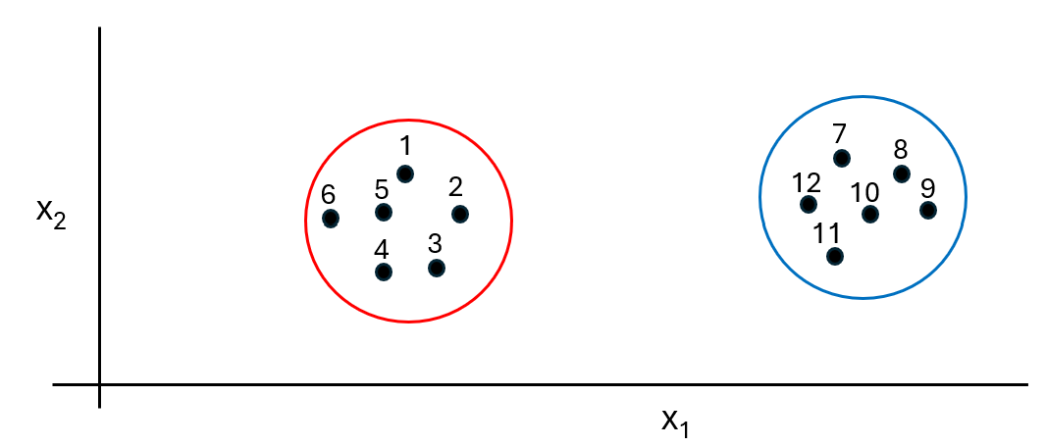

Describe how each of the four agglomerative cluster analysis methods below would measure the similarity (i.e., distance) between the two clusters using Euclidean distance.

  - Nearest neighbor (single linkage)

  - Furthest neighbor (complete linkage)

  - Centroid

  - Average (average linkage)

- (29 total points) Answer the following questions.
  - (8 points) Suppose observations for two variables in a data set are plotted in a scatter plot. There are two other variables that are categorical (qualitative) in this same data set. How could one add these two categorical variables to the plot? Do not include using a Trellis plot in your answer.

  - (7 points) When constructing a scatter plot of scores for two principal components, it is important for the x- and y-axes to be the same numerical range and the plot to be square. Why?

  - (7 points) Below is a bubble plot for three variables x, y, and z, where z corresponds to the bubble. Identify the trend in this plot and describe it with respect to numerical values of the three variables.

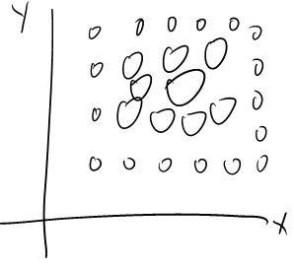

  - (7 points) Identify the main characteristic of all trellis plots that allow these plots to include multiple variables. Explain.

