Test #2 Answers
STAT 494/873
Fall 2025

Complete the problems below. Use R for all calculations and plots. Make sure to fully explain all answers and show your work to receive full credit.

- (20 points) This problem examines a data set containing measurements on two species of finches (a type of bird). The data is in the test2.csv file that is available on the graded web page of the course website. Below is an example of how I read the data into R:

> set1 <- read.csv("C:\\data\\test2.csv")
> head(set1, n = 3)
Species BodyL WingL TailL BeakW BeakH LBeakL UBeakL N.UBkL TarsusL
1 P 112 62 42.0 6.7 8.7 6.0 12.0 8.0 18.3
2 P 115 65 46.0 6.5 8.5 6.5 13.0 8.0 19.0
3 P 112 62 38.5 6.5 8.0 6.0 12.5 8.5 18.0

> tail(set1, n = 3)
Species BodyL WingL TailL BeakW BeakH LBeakL UBeakL N.UBkL TarsusL
101 F 120 64 34.0 9.0 11.0 8.0 16.0 11 21.0
102 F 118 65 38.5 8.5 11.3 8.5 16.5 11 20.0
103 F 120 66 40.0 8.3 11.5 8.5 15.0 10 19.5

The Species variable contains the two types of finch species represented (“P” and “F”). The remaining variables provide measurements on each finch in the sample. The exact meaning of these remaining variables is not important for the test. Do not assume the measurement units for each of the numerical variables are the same. Using this data set, complete the following.
  - (12 points) Construct a parallel coordinate plot for the data. Using this plot, thoroughly describe the differences between the two species of finches. Be specific in referring to specific trends in the plot that led you to your conclusions. You may find the code below helpful:

finch.color <- ifelse(test = set1$Species == "P", yes = "red", no = "blue")

> library(package = MASS)
> parcoord(x = set1[,-1], col = finch.color, main = NA)
> legend(locator(1), legend = c("P", "F"), col = c("red", "blue"), lty = c(1,1), bty
= "n")
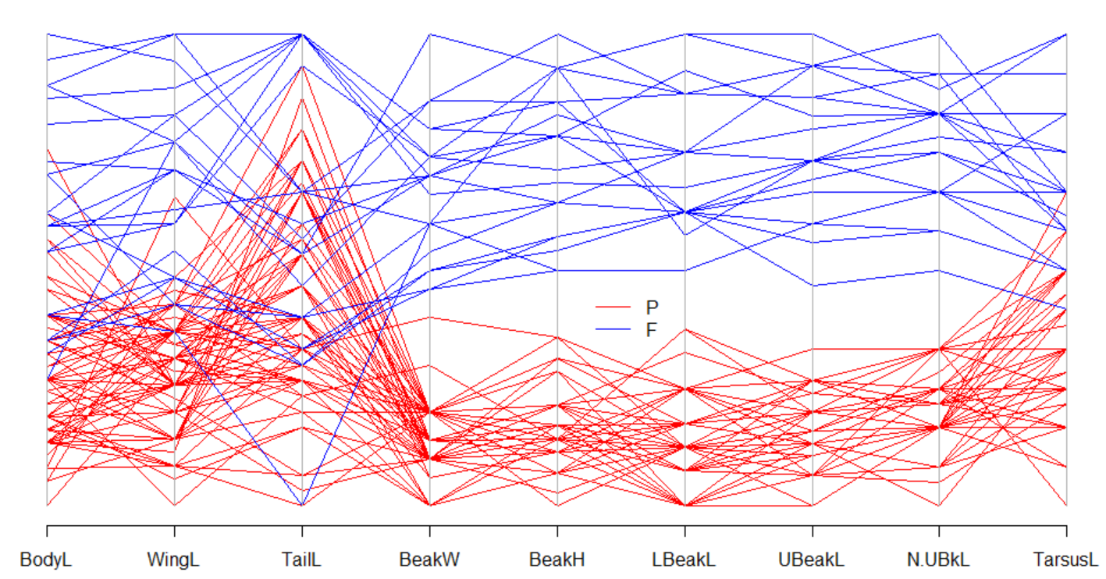

The P observations all have smaller values for BeakW, BeakH, LBeakL, UBeakL, and N.UBkL. This is demonstrated by the lines for this species being below the lines for F.

The P observations also tend to have lower values for BodyL, WinL, and TarsusL variables. The majority of the lines for P are below the lines for F.

Lastly, there are no obvious distinguishable differences for the two species when it comes to TailL.

  - (8 points) Construct a stars plot (each observation is a star). Note that observations 1-81 are for Species = P and observations 82-103 are for Species = F. Describe the differences between the two species of finches. Be specific in referring to specific parts of the plot that led you to your conclusions.

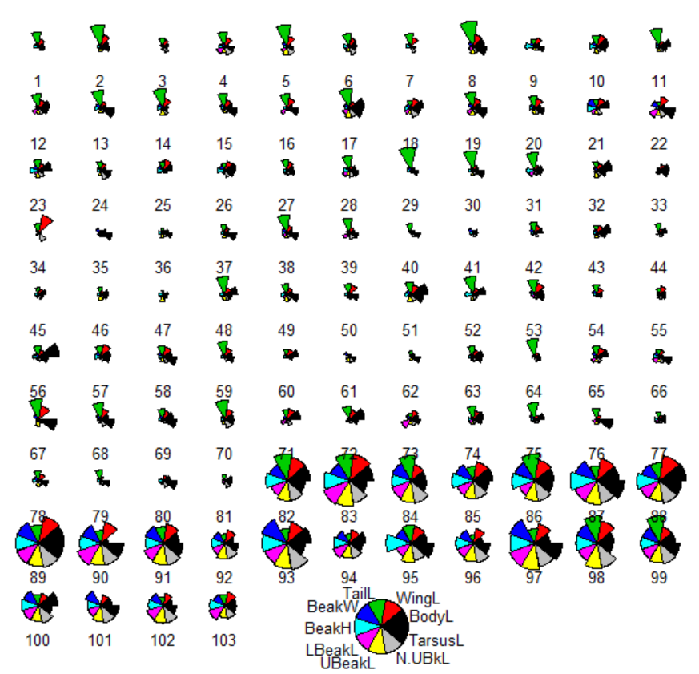

Below is the code that I used to construct the plot.

> stars(x = set1[,-1], draw.segments = TRUE, nrow = 10, key.loc = c(15,1.5), labels
= 1:nrow(set1))

This problem is easy because it can use much of the same answers as part a)!

The P observations all have smaller values for BeakW, BeakH, LBeakL, UBeakL, and N.UBkL. This is demonstrated by the rays not extending out too far from the center. The F observations have larger values for these same variables because the rays extend far out from the center.

The P observations also tend to have lower values for BodyL, WinL, and TarsusL variables. The majority of the rays for P extend out less than those for F.

Lastly, there are no obvious distinguishable differences for the two species when it comes to TailL.

- (31 total points) This problem continues using the finch data set from 1), but now for PCA.
  - (7 points) Why is the correlation matrix more appropriate to use with this data set than the covariance matrix when performing a PCA?

There is a different amount of variation among the variables. And, we do not know if they are measured in the same scale.

> cov(set1[,-1])
BodyL WingL TailL BeakW BeakH
BodyL 63.715591 21.223729 9.999048 6.878584 10.643946
WingL 21.223729 14.043404 6.495626 3.866053 5.721830
TailL 9.999048 6.495626 12.013619 1.557994 2.465247
BeakW 6.878584 3.866053 1.557994 1.480933 2.100274
BeakH 10.643946 5.721830 2.465247 2.100274 3.294986
LBeakL 5.768903 3.235989 1.228937 1.190245 1.749026
UBeakL 10.756587 5.976756 2.683808 2.218383 3.280484
N.UBkL 8.107082 4.638364 1.897777 1.702787 2.482845
TarsusL 5.276156 3.192718 1.403820 1.145993 1.664533
LBeakL UBeakL N.UBkL TarsusL
BodyL 5.7689035 10.756587 8.107082 5.2761565
WingL 3.2359890 5.976756 4.638364 3.1927184
TailL 1.2289368 2.683808 1.897777 1.4038197
BeakW 1.1902446 2.218383 1.702787 1.1459928
BeakH 1.7490263 3.280484 2.482845 1.6645326
LBeakL 1.1036113 1.919036 1.466032 0.9914011
UBeakL 1.9190358 3.709101 2.737302 1.9011479
N.UBkL 1.4660318 2.737302 2.170967 1.3715068
TarsusL 0.9914011 1.901148 1.371507 1.4696497

  - (9 points) How many principal components are appropriate for this data set? Explain.

> pca.cor <- princomp(formula = ~ BodyL + WingL + TailL + BeakW + BeakH + LBeakL +
UBeakL + N.UBkL + TarsusL, data = set1, cor = TRUE, scores = FALSE)
> summary(pca.cor, loadings = TRUE, cutoff = 0.0)
Importance of components:
Comp.1 Comp.2 Comp.3
Standard deviation 2.641363 0.91978869 0.68782195
Proportion of Variance 0.775200 0.09400125 0.05256656
Cumulative Proportion 0.775200 0.86920129 0.92176785
Comp.4 Comp.5 Comp.6
Standard deviation 0.54316562 0.43828184 0.29814159
Proportion of Variance 0.03278099 0.02134344 0.00987649
Cumulative Proportion 0.95454884 0.97589228 0.98576877
Comp.7 Comp.8 Comp.9
Standard deviation 0.235396925 0.210984556 0.167794200
Proportion of Variance 0.006156857 0.004946054 0.003128322
Cumulative Proportion 0.991925625 0.996871678 1.000000000

Loadings:
Comp.1 Comp.2 Comp.3 Comp.4 Comp.5 Comp.6 Comp.7
BodyL 0.295 0.076 0.840 0.403 0.171 0.078 0.046
WingL 0.342 0.145 0.092 -0.085 -0.911 0.059 -0.003
TailL 0.178 0.945 -0.170 -0.042 0.198 0.017 -0.027
BeakW 0.366 -0.117 -0.036 -0.196 0.054 -0.380 0.225
BeakH 0.364 -0.080 0.038 -0.185 0.122 -0.670 -0.385
LBeakL 0.361 -0.159 -0.076 -0.181 0.134 0.545 -0.664
UBeakL 0.368 -0.092 -0.120 -0.103 0.228 0.152 0.250
N.UBkL 0.365 -0.120 -0.076 -0.256 0.112 0.273 0.543
TarsusL 0.315 -0.106 -0.477 0.804 -0.035 -0.049 -0.002
Comp.8 Comp.9
BodyL 0.029 0.013
WingL -0.082 -0.077
TailL 0.051 0.032
BeakW 0.762 -0.184
BeakH -0.410 0.214
LBeakL 0.221 0.044
UBeakL -0.412 -0.724
N.UBkL -0.148 0.614
TarsusL 0.020 0.104

One PC would be appropriate because the number of principal components with an eigenvalue greater than one is only 1! In other words, only one PC accounts for more variation than an original variable. PC #1 has an eigenvalue of 2.64² = 6.97.

I accepted two as an answer as well because it allows one to get over 80% of the variation in the data explained.

  - (8 points) State the first principal component for this data. Make sure to use the correct notation and define the necessary items in the expression!

= 0.295BodyL + 0.342WingL + 0.178TailL + 0.366BeakW + 0.364BeakH + 0.361LBeakL +
0.368UBeakL + 0.365N.UBkL + 0.315TarsusL

where the variables are standardized.

  - (7 points) Thoroughly interpret the first principal component.

This is an overall measure of the finch because all of the coefficients are positive and similar in size. Small (large) values for the variables lead to small (large) values of PC #1.

- (20 total points) Suppose there are two variables x₁ and x₂ and two clusters of observations. Below is a plot of the clusters with the observation numbers included.

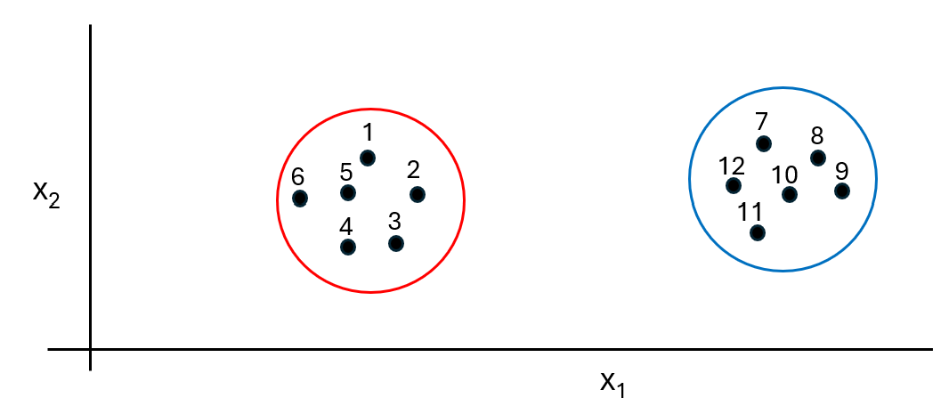

Describe how each of the four agglomerative cluster analysis methods below would measure the similarity (i.e., distance) between the two clusters using Euclidean distance.

  - Nearest neighbor (single linkage) – The distance between observations 2 and 12 (the closest observations between the clusters)
  - Furthest neighbor (complete linkage) – The distance between observations 6 and 9 (the farthest apart observations between the clusters)
  - Centroid – The average values for x₁ and x₂ are found for both clusters. The distance between these averages across clusters is the distance used.
  - Average (average linkage) – All pairwise distances between observations in the clusters are found (1 vs. 7, 1 vs. 8, …, 6 vs. 12). These distances are averaged and used as the distance between the clusters.

- (29 total points) Answer the following questions.
  - (8 points) Suppose observations for two variables in a data set are plotted in a scatter plot. There are two other variables that are categorical (qualitative) in this same data set. How could one add these two categorical variables to the plot? Do not include using a Trellis plot in your answer.

Color, size, type of plotting points

  - (7 points) When constructing a scatter plot of scores for two principal components, it is important for the x- and y-axes to be the same numerical range and the plot to be square. Why?

Each principal component can measure a different amount of variability. By having the axes on the same scale in a square plot ensures that one can properly take into account the differences in the observations plotted.

  - (7 points, plot from graphics notes) Below is a bubble plot for three variables x, y, and z, where z corresponds to the bubble. Identify the trend in this plot and describe it with respect to numerical values of the three variables.

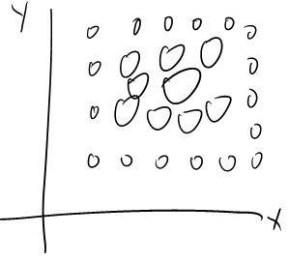
While there is no trend between x and y, we definitely see a trend between these variables and z. Middle values of x and y are associated with larger values of z.

  - (7 points) Identify the main characteristic of all trellis plots that allow these plots to include multiple variables. Explain.

Trellis plots include multiple variables by conditioning on variable values. This produces multiple panels within one plot where each panel is a plot between variables conditioned on values of other variables.

