Test #3
STAT 494/873
Fall 2025

Complete the problems below. Use R for all calculations and plots. Make sure to fully explain all answers and show your work to receive full credit.

- (40 total points) This problem examines a data set containing measurements on two species of finches (a type of bird). The data is in the test3.csv file that is available on the graded web page of the course website. This data is the same as used on Test #2 but only three variables are in it. Below is an example of how I read the data into R.

> set1 <- read.csv(file = "test3.csv")
> head(set1)
Species BodyL WingL
1 P 112 62
2 P 115 65
3 P 112 62
4 P 110 63
5 P 110 64
6 P 115 63

The Species variable contains the two types of finch species represented (“P” and “F”). The remaining variables provide measurements on each finch in the sample. The exact meaning of these remaining variables is not important for the test. The ultimate goal is to predict Species using these remaining variables.

Complete the following parts using this data set.
  - (9 points) For the first observation, write out the matrix form of the Mahalanobis distance for the F population (Species = F) assuming the covariance matrices are equal, prior probabilities are equal, resubstitution is used, and no costs are used. In your answer, you need to write out the correct vectors and matrices with their corresponding observed values. You do NOT need to multiply out the vectors and matrices or find inverses!

  - (8 points) Using linear discriminant analysis, proportional prior probabilities, and cross-validation, insert the number of correct and incorrect classifications in the four empty cells of the table below. Make sure to still include your R code and output!

 |  | Classified
 |  | F | P
Original | F
Original | P

  - (8 points) Continuing b), state the posterior probabilities for observation #1 and show how the classification of this observation is made with them.

  - (8 points) Apply nearest neighbor classification using K = 3, cross-validation, and standardized variables. Set a seed of 5261 before implementing the correct function. Insert the number of correct and incorrect classifications in the four empty cells of the table below. Make sure to still include your R code and output!

 |  | Classified
 |  | F | P
Original | F
Original | P

  - (7 points) Describe the most appropriate process that can be used to determine the “best” value of K to use for nearest neighbor classification with this data. You do NOT need to actually implement it!

- (14 total points) The following questions are regarding the use of logistic regression for classification.
  - (7 points) Show that can be rewritten as . Include all steps in your proof.

  - (7 points) Below is an ROC curve plot without the ROC curve on it! Describe what the best possible ROC curve would look like on this plot when the goal is to correctly classify observations. If you can, you may draw the ROC curve on the plot instead of describing it.

- (26 total points) A cluster analysis is performed on a data set using the furthest neighbor method with standardized variables.
  - Below is the hierarchical tree diagram.

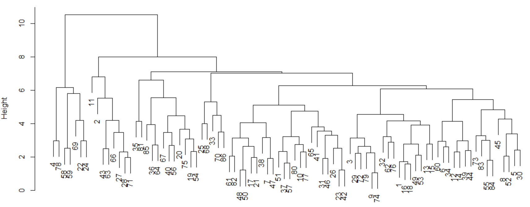
Answer the following questions using the above plot.
    - (6 points) Why are 4 clusters a poor choice for the number of clusters?

    - (6 points) Why are 3 clusters a good choice for the number of clusters?

  - (7 points) Explain how the furthest neighbor method determined which clusters to join together when going from 4 to 3 clusters. Make sure to clearly describe how distance is defined for this clustering method in your explanation.

  - (7 points) Suppose 3 clusters are chosen for this data set. How can principal component analysis be used to determine if 3 is truly a good choice? Be specific about what to look for in the analysis.

- (20 total points) Complete the following:
  - (8 points) When is cluster analysis rather than nearest neighbor classification more appropriate to use? Conversely, when is nearest neighbor classification rather than cluster analysis more appropriate to use?

  - Suppose there are two populations:

Population #1 is characterized by
Population #2 is characterized by

where w > 0 and v > 0. Large samples are taken from each of these populations with the goal of developing a statistical method to correctly classify observations into their corresponding populations.
    - (6 points) Suppose v = 1. As w increases, will statistical methods classify the observations better or worse? Explain.

    - (6 points) Suppose w = 2. Will statistical methods classify the observations better or worse as v increases from a value very close to 0 to a value equal to 1? Explain.

