Project #2 Answers
STAT 705
Fall 2026

The potency values for Project #1 were obtained by sampling from one batch of a drug. When stability testing is performed in actual practice, parts of three batches are put into storage. An item (like a pill) is taken out of storage at regular time points for EACH batch and testing is performed on it.

Below is a simulated data set where the potency of a drug has been measured over time in months. Suppose a single pill has been measured at each time point for each batch.

Time | Potency | Batch |  | Time | Potency | Batch |  | Time | Potency | Batch
3 | 1.009166 | 1 |  | 3 | 0.992527 | 2 |  | 3 | 1.024106 | 3
6 | 1.002971 | 1 |  | 6 | 0.973032 | 2 |  | 6 | 0.993926 | 3
9 | 0.980395 | 1 |  | 9 | 1.012433 | 2 |  | 9 | 1.058894 | 3
12 | 0.986608 | 1 |  | 12 | 1.011277 | 2 |  | 12 | 1.019807 | 3
15 | 1.012001 | 1 |  | 15 | 0.990576 | 2 |  | 15 | 0.976561 | 3
18 | 1.005669 | 1 |  | 18 | 0.995276 | 2 |  | 18 | 0.982859 | 3
21 | 0.991233 | 1 |  | 21 | 0.948351 | 2 |  | 21 | 1.009975 | 3
24 | 0.967089 | 1 |  | 24 | 0.982853 | 2 |  | 24 | 0.978247 | 3
30 | 1.006640 | 1 |  | 30 | 1.008000 | 2 |  | 30 | 1.004217 | 3
36 | 0.954065 | 1 |  | 36 | 0.989702 | 2 |  | 36 | 0.975727 | 3
48 | 0.957294 | 1 |  | 48 | 0.965077 | 2 |  | 48 | 0.968716 | 3
60 | 0.914203 | 1 |  | 60 | 0.939663 | 2 |  | 60 | 0.955092 | 3

For example, the pill taken out of storage at time 3 months for batch #1 had a potency of 100.92% of the pharmaceutical company’s desired potency level. The data are available from the projects web page in the file called project2.csv.

Complete the following problems using α = 0.05 for all inference procedures. Include your R program output with code inside of it for each part and any additional information needed to explain your answer. Your R code and output should be formatted in the same manner as in the course notes.

- (53 total points) Consider the population regression model of

E(potency) = β₀ + β₁time + β₂batch2 + β₃batch3

where

batch2 = 1 for batch #2 and 0 otherwise
batch3 = 1 for batch #3 and 0 otherwise.

  - (5 points) Create a factor in R for the batch variable and use this form of the variable for the remainder of the project. Insert this variable into the data frame containing the data. Use the class(), levels(), and contrasts() functions to verify the variable is a factor, to show the three levels of the variable, and to show how the variable is coded with indicator variables.

> set.3batch <- read.csv(file = "project2.csv")
> head(set.3batch)
time potency batch
1 3 1.0091659 1
2 6 1.0029710 1
3 9 0.9803945 1
4 12 0.9866084 1
5 15 1.0120009 1
6 18 1.0056686 1

> tail(set.3batch)
time potency batch
31 21 1.0099755 3
32 24 0.9782472 3
33 30 1.0042165 3
34 36 0.9757266 3
35 48 0.9687164 3
36 60 0.9550924 3

> set.3batch$batch <- as.factor(set.3batch$batch)
> class(set.3batch$batch)
[1] "factor"
> levels(set.3batch$batch)
[1] "1" "2" "3"
> contrasts(set.3batch$batch)
2 3
1 0 0
2 1 0
3 0 1

  - (3 points) Write out the population regression model for when
    - Batch = 1

E(potency) = β₀ + β₁time

    - Batch = 2

E(potency) = β₀ + β₁time + β₂

    - Batch = 3

E(potency) = β₀ + β₁time + β₃

  - (4 points) What does β₂ and β₃ compare relative to the batches?

β₂ compares batch 2 to batch 1; this is the difference between the models in i) and ii) above

β₃ compares batch 3 to batch 1; this is the difference between the models in i) and iii) above

  - (5 points) Find and state the estimated regression model.

> mod.fit <- lm(formula = Y ~ time + batch, data = set.3batch)
> summary(mod.fit)

Call:
lm(formula = Y ~ time + batch, data = set.3batch)

Residuals:
Min 1Q Median 3Q Max
-0.038515 -0.014540 0.000788 0.011652 0.046967

Coefficients:
Estimate Std. Error t value Pr(>|t|)
(Intercept) 1.0086129 0.0073645 136.955 < 2e-16 ***
time -0.0011206 0.0001983 -5.652 2.98e-06 ***
batch2 0.0017863 0.0080653 0.221 0.826
batch3 0.0133996 0.0080653 1.661 0.106
---
Signif. codes: 0 ‘***’ 0.001 ‘**’ 0.01 ‘*’ 0.05 ‘.’ 0.1 ‘ ’ 1

Residual standard error: 0.01976 on 32 degrees of freedom
Multiple R-squared: 0.5238, Adjusted R-squared: 0.4791
F-statistic: 11.73 on 3 and 32 DF, p-value: 2.399e-05

  - (3 points) Compute CIs for E(potency) for time = 30 and batches 1, 2, and 3. Note that batch needs to be a factor when using predict()!

> predict(object = mod.fit, newdata = data.frame(time = 30, batch = as.factor(c(1,2,3))), interval = "confidence", level = 0.95, se.fit = TRUE)
$fit
fit lwr upr
1 0.9749936 0.9630840 0.9869032
2 0.9767799 0.9648703 0.9886895
3 0.9883931 0.9764836 1.0003027

$se.fit
1 2 3
0.005846817 0.005846817 0.005846817

$df
[1] 32

$residual.scale
[1] 0.01975576

For example, the CI for batch #1 at time = 30 is (0.9631, 0.9869).

  - The purpose of this part is to examine the calculations via matrix algebra.
    - (2 points) What is X? Rather than create it yourself, use a function in R that extracts it from the results of lm(). Show the first two rows and last two rows only.

> X <- model.matrix(mod.fit)
> X[1:2,]
(Intercept) time batch2 batch3
1 1 3 0 0
2 1 6 0 0

> n <- nrow(X)
> X[(n-1):n,]
(Intercept) time batch2 batch3
35 1 48 0 1
36 1 60 0 1

    - (2 points) Create Y in R. Print the first two elements and the last two elements only.

> Y <- as.matrix(set.3batch$potency)
> Y[1:2]
[1] 1.009166 1.002971
> Y[(n-1):n]
[1] 0.9687164 0.9550924

    - (2 points) Compute using matrix algebra computations with Y and X.

> beta.hat <- solve(t(X)%*%X)%*%t(X)%*%Y
> beta.hat
[,1]
(Intercept) 1.008612852
time -0.001120642
batch2 0.001786328
batch3 0.013399558

This matches what lm() computed!

    - (3 points) Compute the CI for E(potency) at time = 30 and batch = 2 using matrix algebra computations with Y and X.

> Xg <- matrix(data = c(1, 30, 1, 0), nrow = 4, ncol = 1, byrow = TRUE)
> sum.fit <- summary(mod.fit)
> VarYhatg <- sum.fit$sigma^2 * t(Xg) %*% solve(t(X)%*%X) %*% Xg
> sqrt(VarYhatg)
[,1]
[1,] 0.005846817

> yhat <- mod.fit$coefficients[1] + mod.fit$coefficients[2]*30 + mod.fit$coefficients[3]
> yhat - qt(1 - alpha/2, df = mod.fit$df.residual)*sqrt(VarYhatg)
[,1]
[1,] 0.9648703
> yhat + qt(1 - alpha/2, df = mod.fit$df.residual)*sqrt(VarYhatg)
[,1]
[1,] 0.9886895

The CI for batch #2 at time = 30 is (0.9649, 0.9887). Notice this matches the interval from the previous part!

  - (5 points) Construct a scatter plot of the data where the plotting point color and character correspond to the batch. Include an appropriate legend. There are a number of ways to get different colors and plotting points for the batches. Before my plot() function code, I included

my.color <- ifelse(test = set1$batch == 1, yes = "red",
ifelse(test = set1$batch == 2, yes = "blue", no = "darkgreen"))

where set1 contains the data. In my plot() code, I included the following:

pch = as.numeric(set1$batch),
col = my.color

> my.color <- ifelse(test = set1$batch == 1, yes = "red", ifelse(test = set1$batch == 2, yes = "blue", no = "darkgreen"))
> plot(x = set.3batch$time, y = set.3batch$potency, xlab = "Time", ylab = "Potency", main = "Potency vs. time",
pch = as.numeric(set1$batch), col = my.color, lwd = 2,
panel.first = grid(col = "gray", lty = "dotted"), ylim = c(min(set.3batch$potency, 0.95), max(set.3batch$potency, 1.05)))
> legend(x = 40, y = 1.05, legend = c("Batch #1", "Batch #2", "Batch #3"), col = c("red", "blue", "darkgreen"), pch = c(1, 2, 3), bty = "n", cex = 0.75)

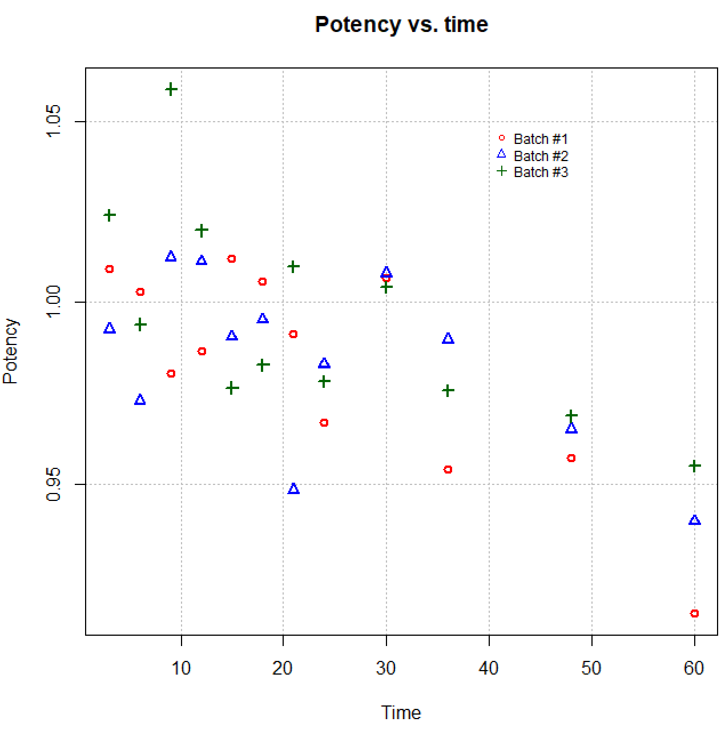

  - (3 points) Add the estimated regression model from d) to the plot. Because there are three batches, there should be three lines on the plot. Make sure the plotted lines for each batch correspond to the same colors as used for the plotting characters. Include a new plot here for your answer.

> curve(expr = predict(object = mod.fit, newdata = data.frame(time = x, batch = as.factor(1))), col = "red", lty = "solid", lwd = 1, add = TRUE, from = min(set.3batch$time), to = max(set.3batch$time), n=1000)
> curve(expr = predict(object = mod.fit, newdata = data.frame(time = x, batch = as.factor(2))), col = "blue", lty = "solid", lwd = 1, add = TRUE, from = min(set.3batch$time), to = max(set.3batch$time), n=1000)
> curve(expr = predict(object = mod.fit, newdata = data.frame(time = x, batch = as.factor(3))), col = "darkgreen", lty = "solid", lwd = 1, add = TRUE, from = min(set.3batch$time), to = max(set.3batch$time), n=1000)
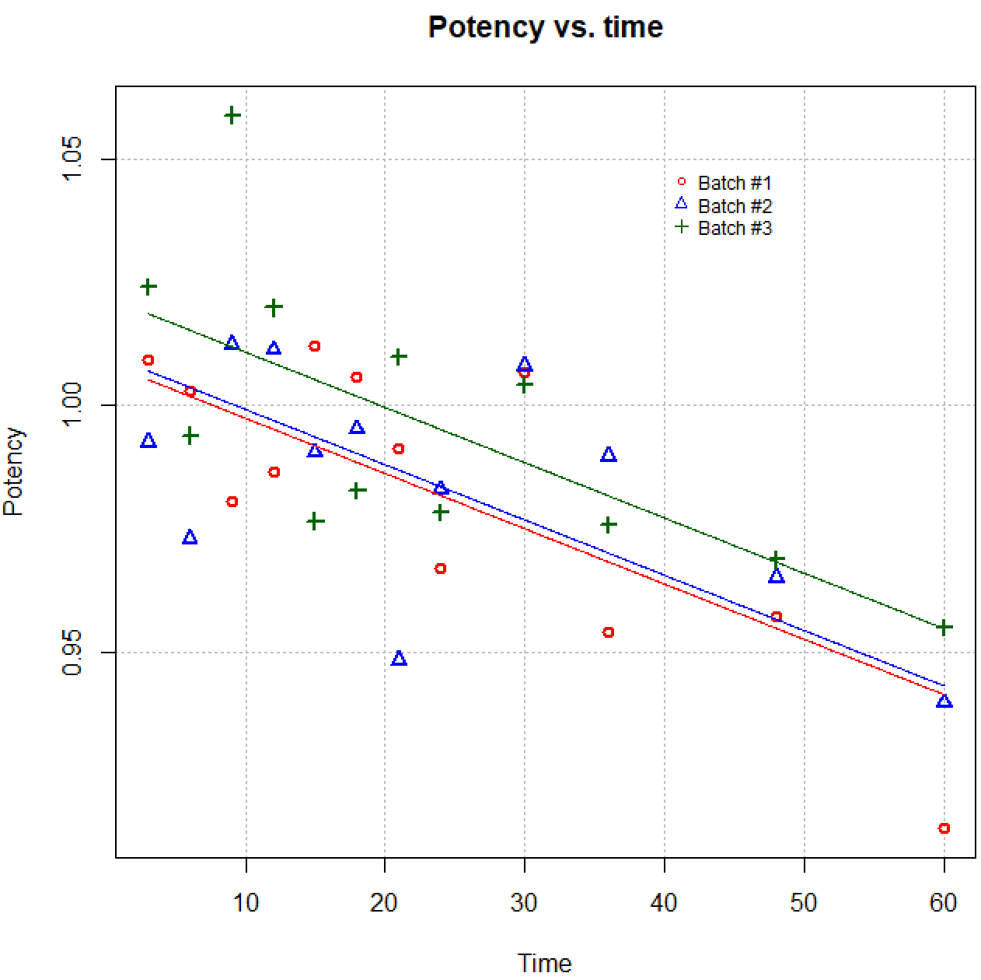

  - (5 points) The FDA procedure to find the shelf life (number of months the drug can be made available for purchase past its manufacture date) uses the same process as described in Project #1. The one difference is CI bands are found for each batch. Add the lower bands to the plot from the last part (include a new plot here for your answer). Also, add a horizontal line at 0.95. The shelf life is the first time that a lower band intersects this horizontal line. What is the shelf life?

> curve(expr = predict(object = mod.fit, newdata = data.frame(time = x, batch = as.factor(1)), interval = "confidence", level = 0.95)[,2], col = "red", lty = "dashed", lwd = 1, add = TRUE, xlim = c(min(set1$time), max(set1$time)))
> curve(expr = predict(object = mod.fit, newdata = data.frame(time = x, batch = as.factor(2)), interval = "confidence", level = 0.95)[,2], col = "blue", lty = "dashed", lwd = 1, add = TRUE, xlim = c(min(set1$time), max(set1$time)))
> curve(expr = predict(object = mod.fit, newdata = data.frame(time = x, batch = as.factor(3)), interval = "confidence", level = 0.95)[,2], col = "darkgreen", lty = "dashed", lwd = 1, add = TRUE, xlim = c(min(set1$time), max(set1$time)))
> abline(h = 0.95, col = "black", lty = "solid")
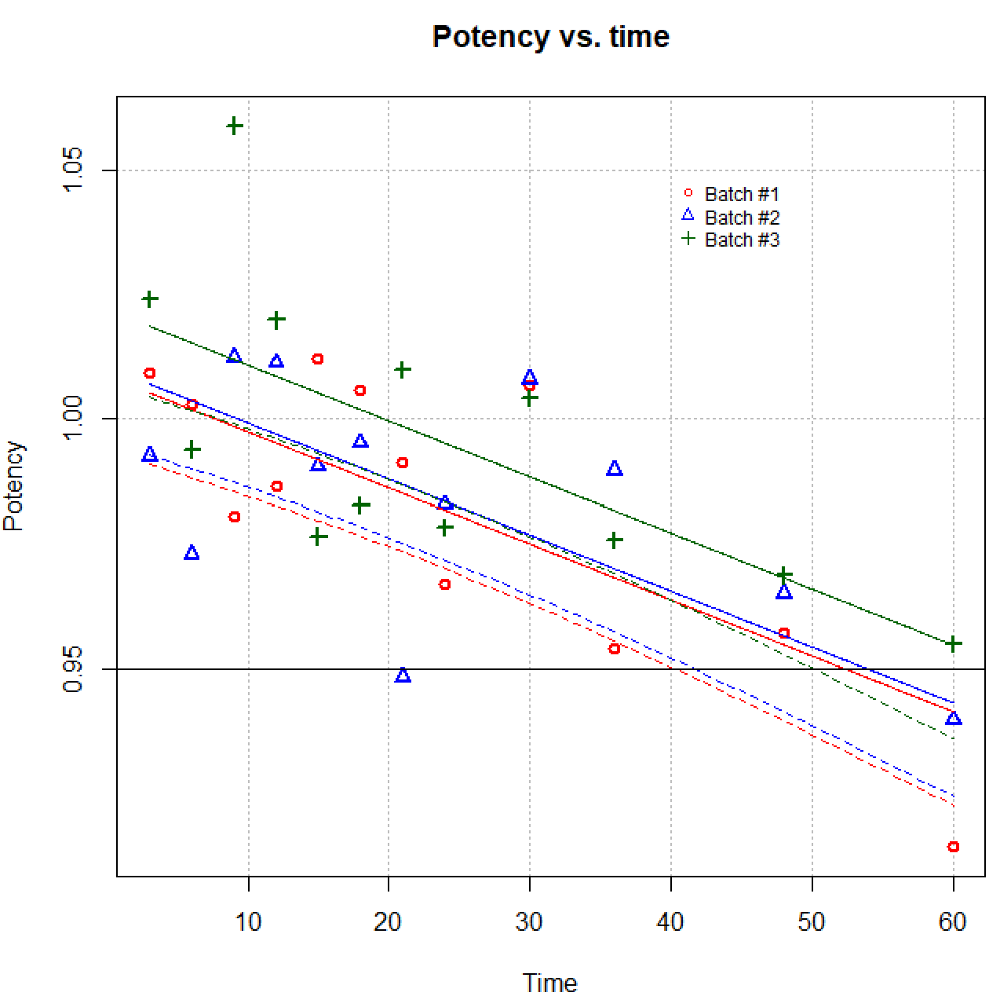

The batch #1 lower band first intersects the horizontal line. This intersection occurs at approximately a time of 40 months.

> # Find root of equation: 0.95 - lower bound = 0
> root.func <- function(x, my.model = mod.fit, batch.number) {
predict(object = my.model, newdata = data.frame(time = x, batch = as.factor(batch.number)), interval = "confidence", level = 0.95)[,2] - 0.95
}
> root.func(x = 40, my.model = mod.fit, batch.number = 1)
[1] 0.00039475

> uniroot(f = root.func, interval = c(30,50), my.model = mod.fit, batch.number = 1)
$root
[1] 40.29838

$f.root
[1] 4.150152e-09

$iter
[1] 4

$init.it
[1] NA

$estim.prec
[1] 6.103516e-05

The shelf life is 40.30 months.

  - (6 points) Perform an F test to evaluate the importance of the batch variable. Describe how the F test result corresponds to what the plot from h) shows.
    - H₀: β₂ = β₃ = 0 vs. H_{a}: At least one β not equal to 0
    - P-value = 0.2123
    - α = 0.05
    - Because 0.2123 > 0.05, do not reject H₀
    - There is not sufficient evidence that batch is important in estimating potency, given time is in the model.

> mod.fit.time <- lm(formula = Y ~ time, data = set.3batch)
> anova(mod.fit.time, mod.fit)
Analysis of Variance Table

Model 1: Y ~ time
Model 2: Y ~ time + batch
Res.Df RSS Df Sum of Sq F Pr(>F)
1 34 0.013760
2 32 0.012489 2 0.0012704 1.6275 0.2123

There is little separation between the red and blue lines, which suggests batches 1 and 2 are very similar. There is some separation between the green and the other lines. However, this separation was not enough to suggest batch has an effect on the potency.

Would a pharmaceutical company prefer a reject or don’t reject H₀ here?

  - (5 points) Examine if there are mean potency differences among the batches when time is in the model. Use the emmeans package. Note that each pairwise combination of the batches needs to be compared! Properly summarize the results.

> library(package = emmeans)
Welcome to emmeans.
Caution: You lose important information if you filter this package's results.
See '? untidy'

> calc.est <- emmeans(object = mod.fit, specs = ~ batch, type = "response")
> calc.est
batch emmean SE df lower.CL upper.CL
1 0.982 0.0057 32 0.971 0.994
2 0.984 0.0057 32 0.972 0.996
3 0.996 0.0057 32 0.984 1.007

Confidence level used: 0.95

> test.info <- contrast(object = calc.est, method = "pairwise", adjust = "none")
> test.info
contrast estimate SE df t.ratio p.value
batch1 - batch2 -0.00179 0.00807 32 -0.221 0.8261
batch1 - batch3 -0.01340 0.00807 32 -1.661 0.1064
batch2 - batch3 -0.01161 0.00807 32 -1.440 0.1596

> ci.info <- confint(object = test.info, adjust = "none", level = 0.95)
> ci.info
contrast estimate SE df lower.CL upper.CL
batch1 - batch2 -0.00179 0.00807 32 -0.0182 0.01464
batch1 - batch3 -0.01340 0.00807 32 -0.0298 0.00303
batch2 - batch3 -0.01161 0.00807 32 -0.0280 0.00482

Confidence level used: 0.95

All three hypothesis tests comparing the batches result in p-values greater than 0.10 (smallest is 0.1064). Therefore, there is not strong evidence to indicate the batches have different means when accounting for time in the model.

Notes:
- Either hypothesis tests or confidence intervals should be given here (both are not needed).
- Because the F test concluded “do not reject H₀” in j), one would normally not look for differences among the batches.

- (5 total points) Include the time and batch interaction term in the model given in 1). Find and state this model. While this project does not have you examine anything further with this model, you should think about how to do other parts of 1) with it!

> mod.fit.inter <- lm(formula = potency ~ time + batch + time:batch, data = set.3batch)
> summary(mod.fit.inter)

Call:
lm(formula = potency ~ time + batch + time:batch, data = set.3batch)

Residuals:
Min 1Q Median 3Q Max
-0.037672 -0.014816 0.000031 0.012376 0.046155

Coefficients:
Estimate Std. Error t value Pr(>|t|)
(Intercept) 1.0152179 0.0099383 102.152 < 2e-16 ***
time -0.0014017 0.0003454 -4.058 0.000325 ***
batch2 -0.0127398 0.0140548 -0.906 0.371928
batch3 0.0081105 0.0140548 0.577 0.568202
time:batch2 0.0006181 0.0004884 1.266 0.215422
time:batch3 0.0002251 0.0004884 0.461 0.648276
---
Signif. codes: 0 ‘***’ 0.001 ‘**’ 0.01 ‘*’ 0.05 ‘.’ 0.1 ‘ ’ 1

Residual standard error: 0.01987 on 30 degrees of freedom
Multiple R-squared: 0.5485, Adjusted R-squared: 0.4732
F-statistic: 7.289 on 5 and 30 DF, p-value: 0.0001427

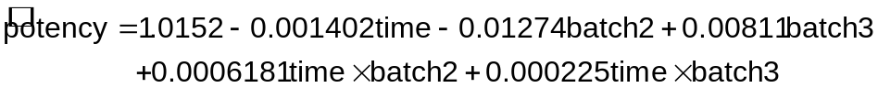

- (3 points) Below is the code that I used to simulate the data. Write out one population regression model from this code. Is there a batch and time interaction present? If not, does batch have an effect on potency? Explain.

# Batch #1
set.seed(9192)
time <- c(3,6,9,12,15,18,21,24,30,36,48,60)
epsilon <- rnorm(n = length(time), mean = 0, sd = 0.014)

beta0 <- 1
beta1 <- -0.001
potency <- beta0 + beta1*time + epsilon

set1 <- data.frame(time, potency)
set1

#Batch #2 and #3
set.seed(1991)
epsilon <- rnorm(n = length(time), mean = 0, sd = 0.014)
potency <- beta0 + beta1*time + 0.01 + epsilon
set2 <- data.frame(time, potency)

epsilon <- rnorm(n = length(time), mean = 0, sd = 0.014)
potency <- beta0 + beta1*time + 0.015 + epsilon
set3 <- data.frame(time, potency)

set.3batch <- rbind(data.frame(set1, batch = 1),
data.frame(set2, batch = 2),
data.frame(set3, batch = 3))
set.3batch

The population regression model is

E(potency) = 1 – 0.001time + 0.01batch2 + 0.015batch3

There is no interaction present, but there is a batch effect (β₂ = 0.01 and β₃ = 0.015). Note that ε ~ N(0, 0.014²)

