**ACF for ARMA**

We will examine the ACF and PACF (a new function) for a specific ARMA process. We can compare these values to their corresponding estimated values from an observed time series. Values and patterns that tend to match the best between the ARMA model and the observed time series suggest a particular model to use for the data.

ACF for MA(q) - Below is the derivation

xt = θ(B)wt

= (1 + θ1B + θ2B2 + … + θqBq)wt

= with θ0 = 1 and

wt~independent (0,) for t = 1, …, n

Note that γ(h) = Cov(xt, xt+h) = E(xtxt+h) – E(xt)E(xt+h) = E(xtxt+h) since E(xt) = E(xt+h) = 0.

When 0 ≤ h ≤ q,

E(xtxt+h)





The last term comes about because E(wt-iwt+h-j) = 0 when -i ≠ h-j and E(wt-iwt+h-j) =  =  when -i = h-j ⇒ j = i+h. One can write out the indices for the summation and then try h = 0, h = 1, … to see there are q - h pairs of indices that match up each time.

Therefore, 

Note that γ(0) = . The ACF is

ρ(h) = γ(h)/γ(0) =

Notes:

* This derivation could have been directly from the linear process result examined earlier;  where it can be shown that  for h ≥ 0.
* For a MA(1):  for h = 0, 1. Then
* γ(0) =  where θ0 = 1,
* γ(1) = , and
* γ(h) = 0 for h > 1.
* The ACF is ρ(0) = 1, ρ(1) = , and ρ(h) = 0 for h > 1.
* Plots from ma1_sim.R using MA(1):



* Suppose you observed a time series. The estimated values of the ACF are  ≠ 0 and  ≈ 0 for h > 1. What may be a good model for the data?
* For a MA(2): . Then
* γ(0) = ,
* γ(1) = ,
* γ(2) = , and
* γ(h) = 0 for h>2.
* The ACF is ρ(0) = 1, ρ(1) = , ρ(2) = , and ρ(h) = 0 for h > 2.
* For a MA(q): ρ(h) = 0 for h > q.
* Suppose you observed a time series. The estimated values of the ACF are  ≠ 0,  ≠ 0, and  ≈ 0 for h > 2. What may be a good model for the data?

ACF for casual ARMA(p,q) - Below is the derivation

First, rewrite the model as an infinite order MA!

ϕ(B)xt = θ(B)wt ⇒ xt = [θ(B)/ϕ(B)]wt ⇒ xt = ψ(B)wt

where

wt ~ independent (0,) for t = 1, …, n

ψ(B) = 1 + Bψ1 + B2ψ2 + …

We can re-write the model as

xt =  with ψ0=1

Note that E(xt) = 0.

Then

= Cov(xt, xt+h)

= E(xtxt+h) because E(xt) = 0



 because E(wt-iwt+h-j)=0 when -i≠h-j and E(wt-iwt+h-j)== when -i=h-j ⇒ j=i+h

Look how similar this is to the proof for MA(q) and for a linear process in general!

To find the autocovariance function for any ARMA process, we can transform the model into an infinite order MA and find the ψ’s!

Another interesting way to solve for the autocovariance function:



where ϕ0 = 1 and θ0 =1 

γ(h) = Cov(xt+h, xt)

= 

because E(xt) = 0 and ϕ(B)xt = θ(B)wt

⇔ xt = ϕ1xt-1 + … + ϕpxt-p + wt + θ1wt-1+ … +θqwt-q ⇒ xt+h = 

Then γ(h)

= 

= 

= 

because

γ(h-j) = E(xtxt+h-j)–E(xt)E(xt+h-j) = E(xtxt+h-j)-0×0 and xt = ψ(B)wt

So γ(h)

=  for h ≥ 0 because we only need the non-zero element of  occurs when -i = h-j ⇔ i = j-h and ψi = 0 for i < 0

Thus, γ(h) =  for 0≤h<max(p, q+1)

and γ(h) =  for h ≥ max(p, q+1)

Note: Dividing the above by γ(0) produces ρ(h)!

Example: ACF from casual ARMA(1,1)

* (1-Bϕ1)xt = (1+θ1B)wt where wt~ind. (0,) for t = 1, …, n
* Note that  can be rewritten as xt = ψ(B)wt. Then (1+ψ1B+ψ2B2+…)(1-ϕ1B) = 1+θ1B. By multiplying out, we obtain

1 + ψ1B + ψ2B2 + … +

-ϕ1B - ϕ1ψ1B2 - ϕ1ψ2B3- … = 1+θ1B

Equating terms produces

B: θ1=ψ1-ϕ1 ⇒ ψ1=θ1+ϕ1

B2: 0=ψ2-ϕ1ψ1 ⇒ ψ2= ϕ1(θ1+ϕ1)

B3: 0=ψ3-ϕ1ψ2 ⇒ ψ3= ϕ1[ϕ1(θ1+ϕ1)] = (θ1+ϕ1)

We can use this result to find the autocovariances:



















* (1-Bϕ1)xt = (1+θ1B)wt can be rewritten as

xt = ϕ1xt-1 + wt + θ1wt-1

Then γ(h) = = ϕ1γ(h-1) +  where θ0 = 1.

Thus,

γ(0) = ϕ1γ(-1) + (θ0ψ0 + θ1ψ1)

= ϕ1γ(1) + (1+ θ1ψ1)

= ϕ1γ(1) + [1+ θ1(θ1+ϕ1)]

= ϕ1γ(1) + [1+ +θ1ϕ1]

and

γ(1) = ϕ1γ(0) + θ1ψ0

= ϕ1γ(0) + θ1 because ψ0 = 1.

* Solving for γ(0) produces:

γ(0) = ϕ1γ(1) + [1+ +θ1ϕ1]

= ϕ1[ϕ1γ(0) + θ1] + [1+ +θ1ϕ1]

⇒ γ(0) - γ(0) = ϕ1θ1 + [1+ +θ1ϕ1]

⇒ γ(0)(1 - ) = [ϕ1θ1 + 1+ +θ1ϕ1]

⇒ γ(0) = 

* Solving for γ(1) produces:

γ(1) = ϕ1γ(0) + θ1

= ϕ1 + θ1

= 

= 

= 

* Note that γ(h) =  for h ≥ max(1, 2). Then

γ(2) = ϕ1γ(1), γ(3) = ϕ1γ(2), …

Thus,



* Finally,

ρ(h) =    
for h ≥ 1

Notes:

* Unlike the ACF for a MA(q), this is not 0 after a particular lag.
* Why do we want to know the ACF of an ARMA(1,1)? If the estimated ACF of a time series data set exhibits similar characteristics (i.e, does not “cut off” to 0, but rather “tails off” to 0), then we may think the time series data set can be modeled with an ARMA(1,1)!

Example: ACF of an AR(p)

* Because q = 0, the autocovariance function is

γ(0) = 

and γ(h) =  for h ≥ 1.

* Suppose p = 1. Then γ(0) =  = ,   
  γ(1) = ϕ1γ(0), γ(2) = ϕ1γ(1), …

Thus, γ(0) =  =  ⇒ γ(0) = .

Also, γ(1) = , γ(2) = , …

Finally, γ(h) = 

The ACF is ρ(h) = 

Remember that -1 < ϕ1 < 1 to ensure stationarity. Notice how ρ(h) will slowly “tail off” to 0. While tailing off, it can be alternating between positive and negative values.

* Suppose p = 2. Then

γ(0) = 

= 

= ,

γ(1) =  = ϕ1γ(0) + ϕ2γ(1),

γ(2) = ϕ1γ(1) + ϕ2γ(0),

γ(3) = ϕ1γ(2) + ϕ2γ(1),

Then ρ(h) = γ(h)/γ(0) = ϕ1ρ(h-1) + ϕ2ρ(h-2) for h ≥ 1

Therefore,

ρ(1) = ϕ1ρ(0) + ϕ2ρ(-1) = ϕ1 + ϕ2ρ(1)

⇒ ρ(1) = ϕ1/(1-ϕ2).

ρ(2) = ϕ1ρ(1) + ϕ2ρ(0) = /(1-ϕ2) + ϕ2 = 

Remember that -1 < ϕ2 < 1, ϕ2 + ϕ1 < 1, and ϕ2 - ϕ1 < 1 to ensure stationarity. Notice how ρ(h) will slowly “tail off” to 0.

Notes:

* Unlike the ACF for a MA(q), the ACF is not 0 after a particular lag.
* Table of ACFs for common ARMA models

|  |  |  |  |  |
| --- | --- | --- | --- | --- |
| AR(1): xt=ϕ1xt-1+wt | | ρ(h) = |  | |
| AR(2):  xt=ϕ1xt-1+ϕ2xt-2+wt | | ρ(h) = | ϕ1ρ(h-1)+ϕ2ρ(h-2) for h1 | |
| MA(1):  xt = θ1wt-1 + wt | | ρ(h) = |  | |
| MA(2):  xt = θ1wt-1 +θ2wt-2+wt | ρ(h) = | | |  |

Remember: “+” signs are used in the moving average operator, θ(B). **Many textbooks use “-“ signs so be careful when you examine these book!!!!** Thus, ACFs may be written a different way.

In summary,

|  |  |  |  |
| --- | --- | --- | --- |
|  | **AR(p)** | **MA(q)** | **ARMA(p,q)** |
| ACF | Tails off to 0 | Cuts off to 0 after lag q | Tails off to 0 after lag q |

* AR(1) with ϕ1 = -0.7 (see ar1_sim.R)



The ARMAacf()function calculated the ACF.

In an upcoming example with arma_sample.R, we will compare these plots to an estimated ACF plot. For example, we will see how to use arima.sim() to simulate observations from an ARMA process. When ϕ1 = -0.7, this is what occurs for a sample of size 1,000 and :

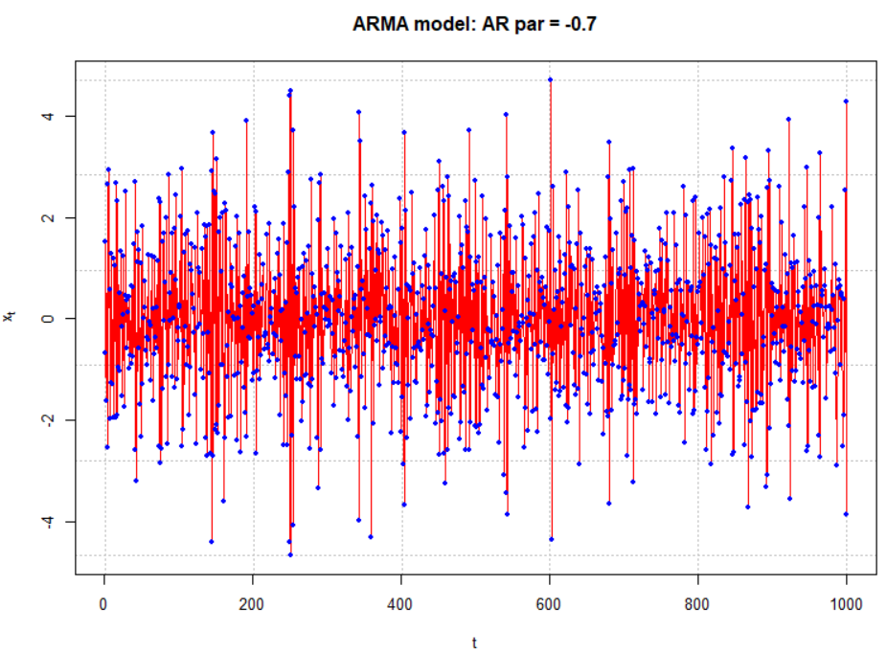

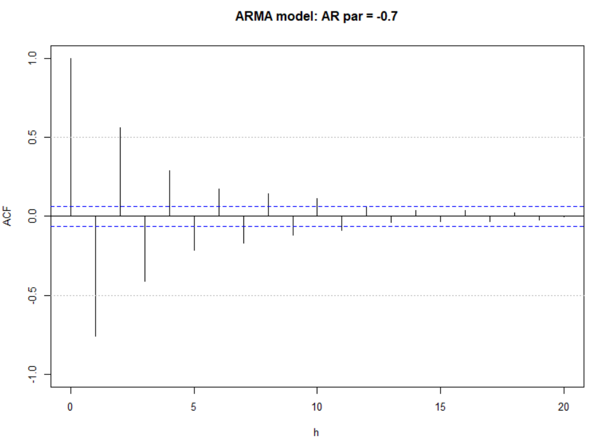

The horizontal lines for the ACF and PACF plots are drawn at ±1.96n-1/2 = ±1.96/.

* Try using the ARMAacf()function to see what other ACF plots would look like for different values of ϕ1!