**Binomial probability distribution**

There are a numbered of other “named” probability distributions for discrete random variables. One of the most useful is the binomial distribution. To help explain the binomial distribution and its characteristics, below is an example.

Example: Field goal kicking

Suppose a field goal kicker attempts 4 field goals during a game and each field goal has the same probability of being successful (the kick is made). Also, assume each field goal is attempted under similar conditions; i.e., distance, weather, surface, … .

Below are the characteristics that must be satisfied in order for the binomial distribution to be used.

1. There are n trials for each experiment.

n = 4 field goals attempted

1. Two possible outcomes of a trial. These are typically referred to as a success or failure.

Each field goal can be made (success) or missed (failure)

1. The trials are independent of each other.

The result of one field goal does not affect the result of another field goal.

1. The probability of success, denoted by π, remains constant for each trial. The probability of a failure is 1-π.

Suppose the probability a field goal is good is 0.6; i.e., P(success) = π = 0.6.

1. The random variable, Y, represents the number of successes.

Let Y = number of field goals that are successful. Thus, Y can be 0, 1, 2, 3, or 4.

What is P(0 of 4 are successful) = P(Y = 0)?

Let G = Field goal is good (success) and M = Field goal is missed (failure)

P(Y = 0)

= P(1st M ∩ 2nd M ∩ 3rd M ∩ 4th M)

= P(1st M)×P(2nd M) ×P(3rd M)×P(4th M) because ind.



= P(M)×P(M)×P(M)×P(M) each trial has same prob.

= (1 – π)4

= 0.44

= 0.0256

What is P(1 good) = P(Y = 1)?

P(Y = 1)

= P(1st G ∩ 2nd M ∩ 3rd M ∩ 4th M) +

P(1st M ∩ 2nd G ∩ 3rd M ∩ 4th M) +

P(1st M ∩ 2nd M ∩ 3rd G ∩ 4th M) +

P(1st M ∩ 2nd M ∩ 3rd M ∩ 4th G)

= P(G)×P(M)×P(M)×P(M) + P(M)×P(G)×P(M)×P(M)

+ P(M)×P(M)×P(G)×P(M) + P(M)×P(M)×P(M)×P(G)

= (0.6)(0.4)(0.4)(0.4) + … + (0.4)(0.4)(0.4)(0.6)

= 4(0.6)(0.4)(0.4)(0.4)

= 4(0.6)1(0.4)3

= 0.1536

Note: P(Y = 1) = 4(0.6)1(0.4)3

* 1 success, with probability of 0.6
* 3 failures, with probability of 0.4
* 4 different ways for 1 success and 3 failures to happen.

Continuing this same process, the probability distribution can be found to be:

|  |  |
| --- | --- |
| **y** | **P(Y = y)** |
| 0 | 0.0256 |
| 1 | 0.1536 |
| 2 | 6(0.6)2(0.4)2=0.3456 |
| 3 | 4(0.6)3(0.4)1=0.3456 |
| 4 | 1(0.6)4(0.4)0=0.1296 |

In general, the equation for the binomial PDF is

 for y = 0, 1, 2, …, n

Notes:

* : This gives the number of unique *combinations* of ways to choose “y” items from “n” items. For this case, we are choosing y successes out of n trails which result in a success or failure. Often, it is read as “n choose y”. More information on combinations is given at the end of the binomial distribution sub-section.
* Remember that n! = n×(n-1)×(n-2)×…×2×1.
* When referring to a binomial PDF in general, we often say Y represents the number of successes and π represents the probability of success on each trial.
* π is a population parameter. We will learn later how to estimate it using a sample from the population. We will also learn how to estimate it with a specific level of confidence!
* The dbinom() function can be used to find these probabilities in R.
* The binomial CDF is



Thus,



The pbinom() function can be used to find F(y) in R.

With only one trial (n = 1), the binomial PDF simplifies to

 for y = 0, 1

because  is 1 for y = 0 and 1. This special case is called a Bernoulli PDF. Also, if Y1, …, Yn are independent random variables with this Bernoulli PDF,  has a binomial PDF of

 for w = 0, 1, 2, …, n

For this reason, one often refers to each “trial” for a binomial setting as a “Bernoulli trial”.

Example: Field goal kicking (FG.R)

> # y = 2, n = 4, pi = 0.6

> dbinom(x = 2, size = 4, prob = 0.6)

[1] 0.3456

> # n = 4, pi = 0.6, y = 0, 1, 2, 3, 4

> dbinom(x = 0:4, size = 4, prob = 0.6)

[1] 0.0256 0.1536 0.3456 0.3456 0.1296

> # CDF n = 4, pi = 0.6, y = 1

> pbinom(q = 1, size = 4, prob = 0.6)

[1] 0.1792

> sum(dbinom(x = 0:1, size = 4, prob = 0.6))

[1] 0.1792

> #Nice display

> data.frame(y = 0:4, fy = dbinom(x = 0:4, size = 4, prob =

0.6), Fy = pbinom(q = 0:4, size = 4, prob = 0.6))

y fy Fy

1 0 0.0256 0.0256

2 1 0.1536 0.1792

3 2 0.3456 0.5248

4 3 0.3456 0.8704

5 4 0.1296 1.0000

> # Plot

> n <- 4

> y <- 0:n

> pi <- 0.6

> plot(x = y, y = dbinom(x = y, size = n, prob = pi), type

= "h", xlab = "y", ylab = "f(y)", main = "Plot of a

binomial distribution for n = 4 and pi = 0.6",

panel.first = grid(col = "gray", lty = "dotted"), lwd =

2, col = "red", ylim = c(0,0.4))

> abline(h = 0)

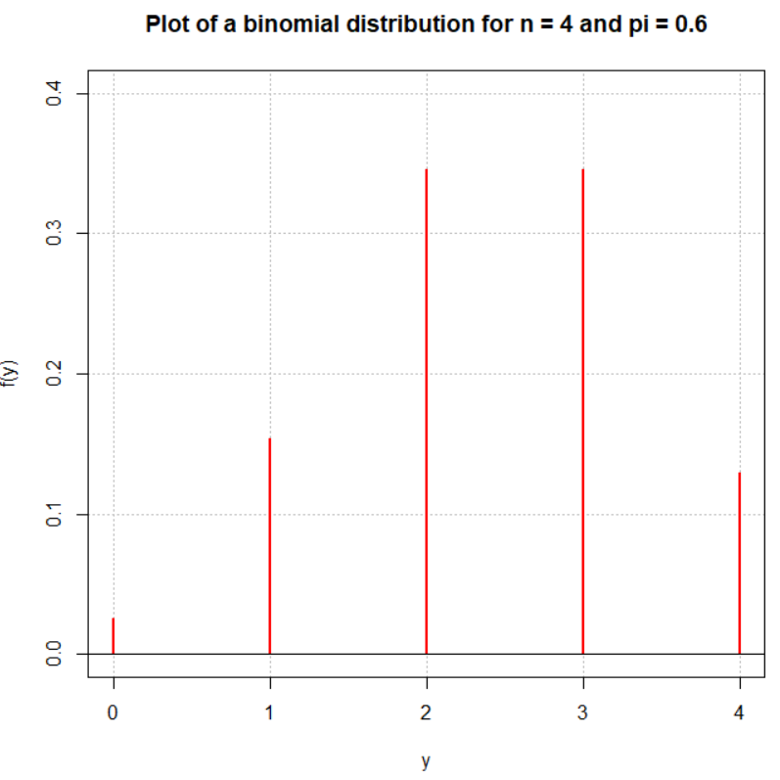

Simulate sample in R:

> set.seed(8239) # Set a seed to reproduce result

> y <- rbinom(n = 10000, size = 4, prob = 0.6)

> head(y)

[1] 1 3 4 2 2 2

> tail(y)

[1] 2 2 2 1 3 3

> # Frequencies and relative frequencies

> table(y)

y

0 1 2 3 4

263 1510 3454 3520 1253

> table(y)/length(y)

y

0 1 2 3 4

0.0263 0.1510 0.3454 0.3520 0.1253

Notice how similar the relative frequencies are to f(y)!

> # Histogram - bar placement is a little off due to the

discreteness

> hist(y, main = "")

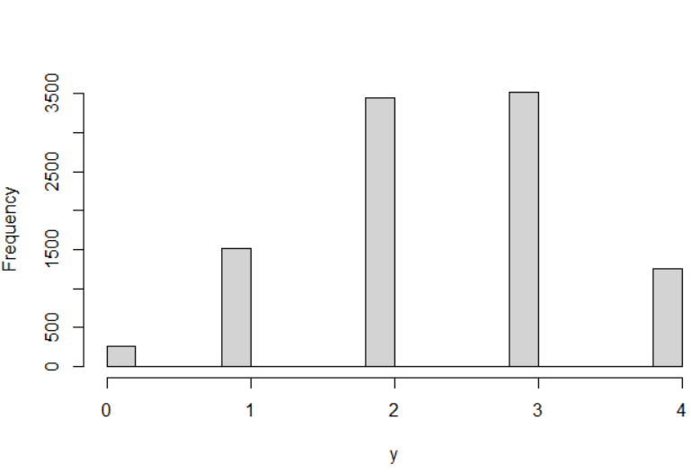

> save.count <- table(y)

> barplot(height = save.count, names = c("0", "1", "2",

"3", "4"), xlab = "y")

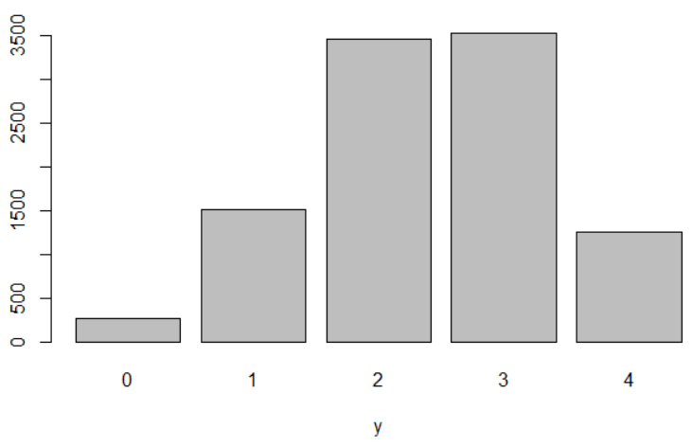

What would we expect the number of successes to be on average? This can be found with E(Y)! The end result is E(Y) = nπ.

proof:

E(Y) = 

= 

= 

=  since y = 0 does not contribute to the sum

= 

=  where u = y - 1

=  since a binomial PDF with n-1 trials is

inside the sum!

= nπ

Take special note of how I got a binomial PDF inside the sum and use the property of it summing to 1. This is a common “trick” that often appears in doing proofs like these!

A similar proof can be used to find E(Y2) = nπ(1 - π + nπ). This leads to

Var(Y) = E(Y2) – [E(Y)]2 = nπ(1-π)

Thus, the mean and variance for a binomial random variable are:

 and 

Questions:

* Why does  make some intuitive sense?
* What does Chebyshev’s Rule say are likely values of y?

Example: Binomial symbolic calculations (binomial.ipnyb)

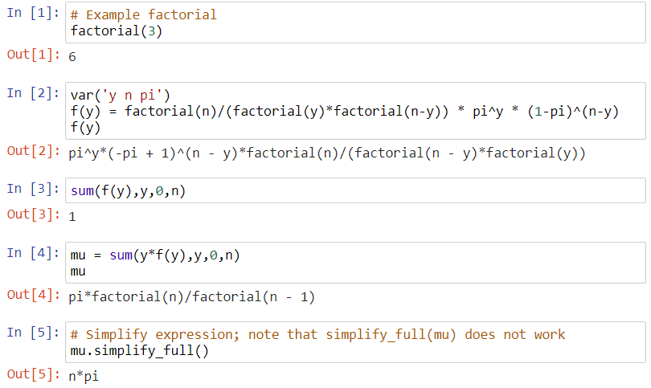

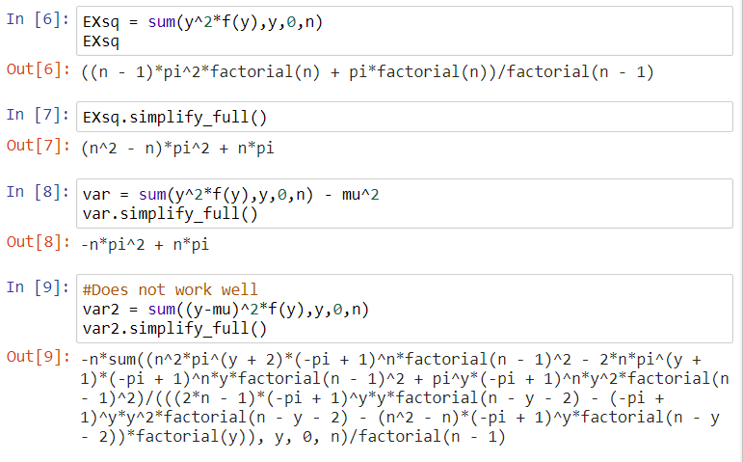

Example: FG kicking (FG.R)

Remember that n = 4 and π = 0.6.

Find the mean and variance.

μ = 4×0.6 = 2.4

σ2 = 4×0.6×(1-0.6) = 0.96

If one used the long way to find μ,

| **y** | **f(y)** | **y×f(y)** |
| --- | --- | --- |
| 0 | 0.0256 | 0 |
| 1 | 0.1536 | 0.1536 |
| 2 | 0.3456 | 0.6912 |
| 3 | 0.3456 | 1.0368 |
| 4 | 0.1296 | 0.5184 |

μ =  = 0 + 0.1536 + 0.6912 + 1.0368 + 0.5184   
 = 2.4

μ ± 2σ = 2.4 ± 2× = (0.44, 4.36)

Suppose a field goal kicker made 0 out of 4 field goals during a game. Based on the information above, what could we conclude about the kicker?

He had a very unusual game. Alternatively, perhaps π = 0.6 is too high. Maybe we could use this information to test a hypothesis about the true value of π.

Compare E(Y) and Var(Y) to estimates from sample:

> # Compare to E(Y) and Var(Y)

> mean(y)

[1] 2.399

> var(y)

[1] 0.950294

Questions:

* Will the sample mean tend to get closer or farther way from E(Y) as the sample size increases?
* Will the sample variance tend to get closer or farther way from E(Y) as the sample size increases?

Example: Binomial distribution plots (binomial_plots.R)

See the program for code. Note that f(y) is displayed on the y-axis despite the label being omitted.









Questions/comments:

* When are the plots “symmetric” and when are the plots “skewed”?
* Where is the largest probability?
* Notice the μ ± 2σ lines.
* We will learn later in this course how to estimate π using a sample from a population. Given the results of these plots, why do you think it is important to estimate it with a sample instead of just setting it to a particular value of choice?

Final notes:

* The multinomial probability distribution is an extension of the binomial distribution to the case of more than two possible categories of outcomes.
* One limitation of the binomial distribution is that π remains constant for each trial. How could we remove this limitation? For example, the probability of success for a field goal is highly dependent of its distance. How could we incorporate distance into a binomial distribution setting?

More about “combinations”

The number of combinations of n distinct objects take r at a time is



Note that the order in selecting the objects (items) is not important. Often  is read as “n choose r”.

Example: How many ways can TWO of the letters a, b, and c be chosen from the three?

First, it is instructive to answer the question, “How many ways can two of the letters a, b, and c be arranged?”

|  | **Letter 1** | **Letter 2** |
| --- | --- | --- |
| 1 | a | b |
| 2 | a | c |
| 3 | b | a |
| 4 | b | c |
| 5 | c | a |
| 6 | c | b |

To answer the original question of “How many ways can two of the letters a, b, and c be chosen from the three?” there is no longer a distinction between cases like (a,b) and (b,a). Thus, order is no longer important. Then,

|  |  |  |
| --- | --- | --- |
|  | **Letter 1** | **Letter 2** |
| 1 | a | b |
| 2 | a | c |
| 3 | b | a |
| 4 | b | c |
| 5 | c | a |
| 6 | c | b |

only (a,b), (a,c), and (b,c) remain. We could also calculate .

Example: How many different number combinations are there in the Pick 5 game of a lottery (5 numbers 1 through 38 are picked)?

|  | **#1** | **#2** | **#3** | **#4** | **#5** |
| --- | --- | --- | --- | --- | --- |
| 1 | 1 | 2 | 3 | 4 | 5 |
| 2 | 1 | 2 | 3 | 4 | 6 |
|  |  |  |  |  |  |
| 501,942 | 34 | 35 | 36 | 37 | 38 |

 = 501,942