Project #4 Answers
STAT 475/875
Spring 2026

Complete the following problems below. Include your R program output with code inside of it for each part and any additional information needed to explain your answer. Your R code and output should be formatted in the same manner as in past project answer keys.

- (20 total points) Pneumoconiosis (black lung disease) is a disease that results from breathing dust from a coal mine. The project4.csv file contains the counts of coal miners aggregated into eight groups based on their time working in a mine (time, years) and their severity of pneumoconiosis (resp, three levels: normal < mild < severe). Below is part of the data:

> project4 <- read.csv(file = "project4.csv", stringsAsFactors = TRUE)
> head(project4, n = 3)
time count resp
1 5.8 98 normal
2 15.0 51 normal
3 21.5 34 normal

> tail(project4, n = 3)
time count resp
22 39.5 8 severe
23 46.0 10 severe
- 51.5 5 severe

The count column represents the number of individuals who had a specific time and pneumoconiosis level.

The purpose of this problem is to examine a multinomial regression model that uses time (linear form) to estimate resp. Note that the weights argument needs to be used with multinom()!
  - (4 points) Estimate and state this model.

> mod.fit.nom <- multinom(formula = resp ~ time, data = project4, weights = count)
# weights: 9 (4 variable)
initial value 407.585159
iter 10 value 208.724810
final value 208.724782
converged

> summary(mod.fit.nom)
Call:
multinom(formula = resp ~ time, data = set1, weights = count)

Coefficients:
(Intercept) time
normal 4.2916723 -0.08356506
severe -0.7681706 0.02572027

Std. Errors:
(Intercept) time
normal 0.5214110 0.01528044
severe 0.7377192 0.01976662

Residual Deviance: 417.4496
AIC: 425.4496

and

  - (3 points) State the estimated model from a) with the normal category as the base level for the response variable. Complete this part without re-estimating the model! You may re-estimate the model only to check your answer.

This re-structuring may be more desirable so that comparisons are made directly with normal (no disease).

For the first part of the model, we just need to multiply by -1:

For the second part of the model, we can subtract the original first part from the second part:

Below is my check.

> project4$resp.order <- factor(project4$resp, levels = c("normal", "mild", "severe"))
> mod.fit.nom.order <- multinom(formula = resp.order ~ time, data = project4, weights = count)
# weights: 9 (4 variable)
initial value 407.585159
iter 10 value 208.809599
final value 208.724782
converged

> summary(mod.fit.nom.order)
Call:
multinom(formula = resp.order ~ time, data = project4, weights = count)

Coefficients:
(Intercept) time
mild -4.291680 0.08356529
severe -5.059849 0.10928549

Std. Errors:
(Intercept) time
mild 0.5214120 0.01528046
severe 0.5964319 0.01646978

Residual Deviance: 417.4496
AIC: 425.4496

  - (3 points) Assess the importance of time using an LRT. Make sure to properly state the hypotheses, the decision, and the conclusion.

> Anova(mod.fit.nom)
# weights: 6 (2 variable)
initial value 407.585159
final value 252.581039
converged
Analysis of Deviance Table (Type II tests)

Response: resp
LR Chisq Df Pr(>Chisq)
time 87.713 2 < 2.2e-16 ***
---
Signif. codes: 0 ‘***’ 0.001 ‘**’ 0.01 ‘*’ 0.05 ‘.’ 0.1 ‘ ’ 1

H₀: β₂₁ = β₃₁ = 0 vs. H_{a}: β₂₁ ≠ 0 and/or β₃₁ ≠ 0
-2log(Λ) = 87.71

Because the p-value is extremely small, reject the null hypothesis. There is sufficient evidence to conclude that pneumoconiosis severity is dependent on time.

  - (3 points) Estimate the probabilities for the pneumoconiosis categories for each time group and display these probabilities in an appropriate data frame. This data frame should be structured as shown below.

time | normal | mild | severe
5.8
15.0
51.5

> pi.hat <- predict(object = mod.fit.nom, newdata = project4, type = "probs")
> data.frame(time = project4[1:8,"time"], normal = round(pi.hat[1:8,2],2), mild = round(pi.hat[1:8,1],2), severe = round(pi.hat[1:8,3],2))
time normal mild severe
1 5.8 0.97 0.02 0.01
2 15.0 0.93 0.04 0.03
3 21.5 0.87 0.07 0.06
4 27.5 0.79 0.11 0.10
5 33.5 0.68 0.15 0.17
6 39.5 0.54 0.20 0.26
7 46.0 0.38 0.25 0.37
8 51.5 0.26 0.27 0.47

  - (3 points) Plot the estimated model. Describe the relationship between pneumoconiosis and time.

> # Normal
> curve(expr = predict(object = mod.fit.nom, newdata = data.frame(time = x), type = "probs")[,2], ylab = expression(hat(pi)), xlab = "Time", xlim = c(min(project4[1:8,"time"]), max(project4[1:8,"time"])), col = "black", lty = "solid", lwd = 2, n = 1000, panel.first = grid(col = "gray", lty = "dotted"), ylim = c(0,1))

> # Mild
> curve(expr = predict(object = mod.fit.nom, newdata = data.frame(time = x), type = "probs")[,1], col = "green", lty = "dotdash", lwd = 2, n = 1000, add = TRUE)

> # Severe
> curve(expr = predict(object = mod.fit.nom, newdata = data.frame(time = x), type = "probs")[,3], col = "red", lty = "longdash", lwd = 2, n = 1000, add = TRUE)

> legend(x = 5, y = 0.6, seg.len = 4, legend = c("Normal", "Mild", "Severe"), lty = c("solid", "dotdash", "longdash"), col = c("black", "green", "red"), bty = "n", lwd = 2)

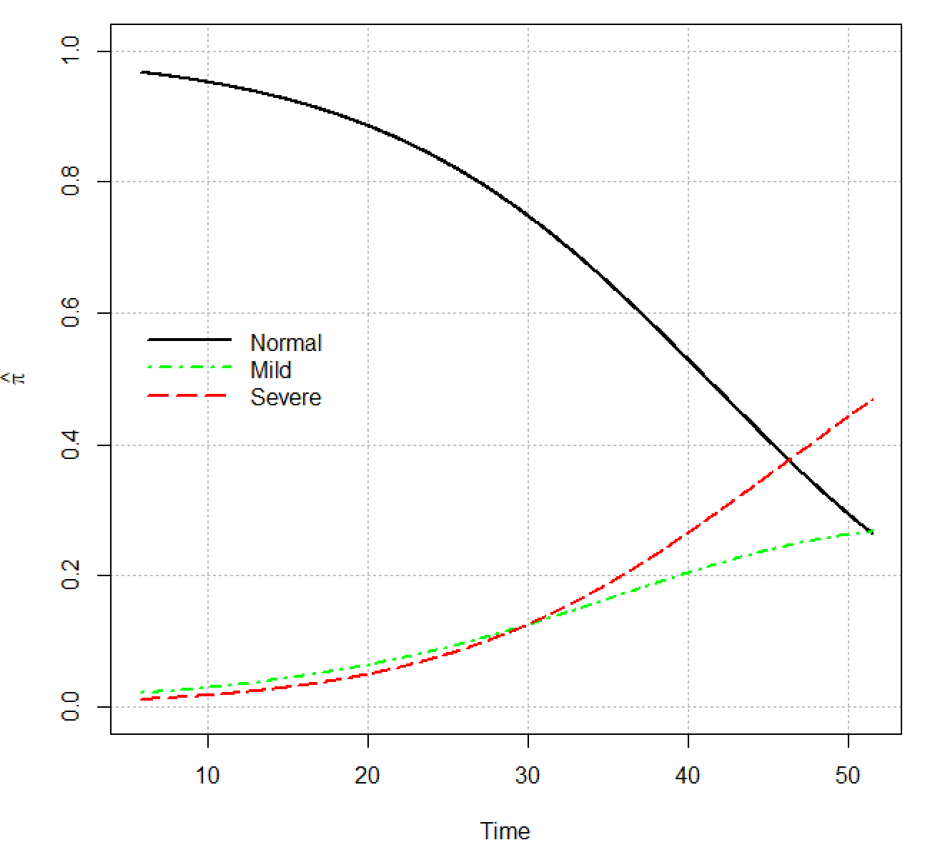
As exposure time increases, the estimated probability of having a more serious form of pneumoconiosis increases.

  - (4 points) Estimate the appropriate odds ratios to fully understand the relationships between time and pneumoconiosis. Include 95% Wald intervals. Don’t use the emmeans package for your calculations. Fully interpret the odds ratios in the context of the data. Use a 5-year increase in time with your calculations.

> exp(5*coefficients(mod.fit.nom)[,2])
normal severe
0.6581151 1.1367910
> exp(-5*coefficients(mod.fit.nom)[,2])
normal severe
1.5194910 0.8796692

The estimated odds of a normal response vs. a mild response change by 0.66 times for every 5-year increase in exposure time. Equivalently, the estimated odds of a mild response vs. a normal response change by 1.52 times for every 5-year increase in time.

The estimated odds of a severe response vs. a mild response change by 1.14 times for every 5-year increase in exposure time.

For the comparison of normal to severe, we can use the results from part b).

> exp(5*coefficients(mod.fit.nom.order)[,2])
mild severe
1.518657 1.727072

> exp(-5*coefficients(mod.fit.nom.order)[,2])
mild severe
0.6584765 0.5790147

The estimated odds of a severe response vs. a normal response change by 1.73 times for every 5-year increase in time.

Below are the calculations for the confidence intervals.

> conf.beta <- confint(object = mod.fit.nom, level = 0.95)
> conf.beta
, , normal

2.5 % 97.5 %
(Intercept) 3.2697255 5.31361901
time -0.1135142 -0.05361594

, , severe

2.5 % 97.5 %
(Intercept) -2.21407362 0.67773245
time -0.01302159 0.06446212

> round(exp(5*conf.beta[2,,1]),2)
2.5 % 97.5 %
0.57 0.76
> rev(round(exp(-5*conf.beta[2,,1]),2))
97.5 % 2.5 %
1.31 1.76
> round(exp(5*conf.beta[2,,2]),2)
2.5 % 97.5 %
0.94 1.38

With 95% confidence, the odds of a normal response vs. a mild response change by 0.57 to 0.76 times for every 5-year increase in exposure time. Equivalently with 95% confidence, the odds of a mild response vs. a normal response change by 1.31 to 1.76 times for every 5-year increase in exposure time.

With 95% confidence, the odds of a severe response vs. a mild response change by 0.94 to 1.38 times for every 5-year increase in exposure time.

For the comparison of normal to severe, we can again use the results from part b).

> conf.beta.order <- confint(object = mod.fit.nom.order, level = 0.95)
> conf.beta.order
, , mild

2.5 % 97.5 %
(Intercept) -5.31362890 -3.2697316
time 0.05361613 0.1135144

, , severe

2.5 % 97.5 %
(Intercept) -6.22883399 -3.8908638
time 0.07700531 0.1415657

> round(exp(5*conf.beta.order[2,,2]),2)
2.5 % 97.5 %
1.47 2.03

> rev(round(exp(-5*conf.beta.order[2,,2]),2))
97.5 % 2.5 %
0.49 0.68

With 95% confidence, the odds of a severe response vs. a normal response change by 1.47 to 2.03 times for every 5-year increase in time.

- (15 total points) For a proportional odds regression model estimated by polr(), complete the same parts as in 1) except for part b. Below are a few notes:
- The response levels need to be ordered correctly!!! You should create this ordering FIRST!!!
- Remember to use the weights argument.
- For the plot part, include your model on the same plot as in part e).
- For the odds ratio part, use profile LR intervals.

Part a) (3 points)

> library(package = MASS)
> mod.fit.ord <- polr(formula = resp.order ~ time, data = project4, weights = count, method = "logistic")
> summary(mod.fit.ord)

Re-fitting to get Hessian

Call:
polr(formula = resp.order ~ time, data = project4, weights = count,
method = "logistic")

Coefficients:
Value Std. Error t value
time 0.0959 0.01194 8.034

Intercepts:
Value Std. Error t value
normal|mild 3.9558 0.4097 9.6558
mild|severe 4.8690 0.4411 11.0383

Residual Deviance: 416.9188
AIC: 422.9188

The estimated model is where and

Part c) (3 points)

> Anova(mod.fit.ord)
Analysis of Deviance Table (Type II tests)

Response: resp.order
LR Chisq Df Pr(>Chisq)
time 88.243 1 < 2.2e-16 ***
---
Signif. codes: 0 ‘***’ 0.001 ‘**’ 0.01 ‘*’ 0.05 ‘.’ 0.1 ‘ ’ 1

The hypothesis test of

H₀: β₁ = 0 vs. H_{a}: β₁ ≠ 0

results in -2log(Λ) = 88.243. Because the p-value is extremely small, reject the null hypothesis. There is sufficient evidence to conclude that pneumoconiosis category is dependent on exposure time.

Part d) (3 points) and Part e) (3 points)

Below are the estimated probabilities and the corresponding plot of the model. The wider lines on the plot are for the proportional odds regression model.

> pi.hat.ord <- predict(object = mod.fit.ord, newdata = project4, type = "probs")
> data.frame(time = project4[1:8,"time"], normal = round(pi.hat.ord[1:8,1],2), mild = round(pi.hat.ord[1:8,2],2), severe = round(pi.hat.ord[1:8,3],2))
time normal mild severe
1 5.8 0.97 0.02 0.01
2 15.0 0.93 0.04 0.03
3 21.5 0.87 0.07 0.06
4 27.5 0.79 0.11 0.10
5 33.5 0.68 0.16 0.16
6 39.5 0.54 0.20 0.25
7 46.0 0.39 0.22 0.39
8 51.5 0.27 0.21 0.52

> #Plot
> lwd.po <- 4
> # Normal
> curve(expr = predict(object = mod.fit.ord, newdata = data.frame(time = x), type = "probs")[,1], col = "black", add = TRUE, lty = "solid", lwd = lwd.po, n = 1000)
> # Mild
> curve(expr = predict(object = mod.fit.ord, newdata = data.frame(time = x), type = "probs")[,2], col = "green", add = TRUE, lty = "dotdash", lwd = lwd.po, n = 1000)
> # Severe
> curve(expr = predict(object = mod.fit.ord, newdata = data.frame(time = x), type = "probs")[,3], col = "red", add = TRUE, lty = "longdash", lwd = lwd.po, n = 1000)
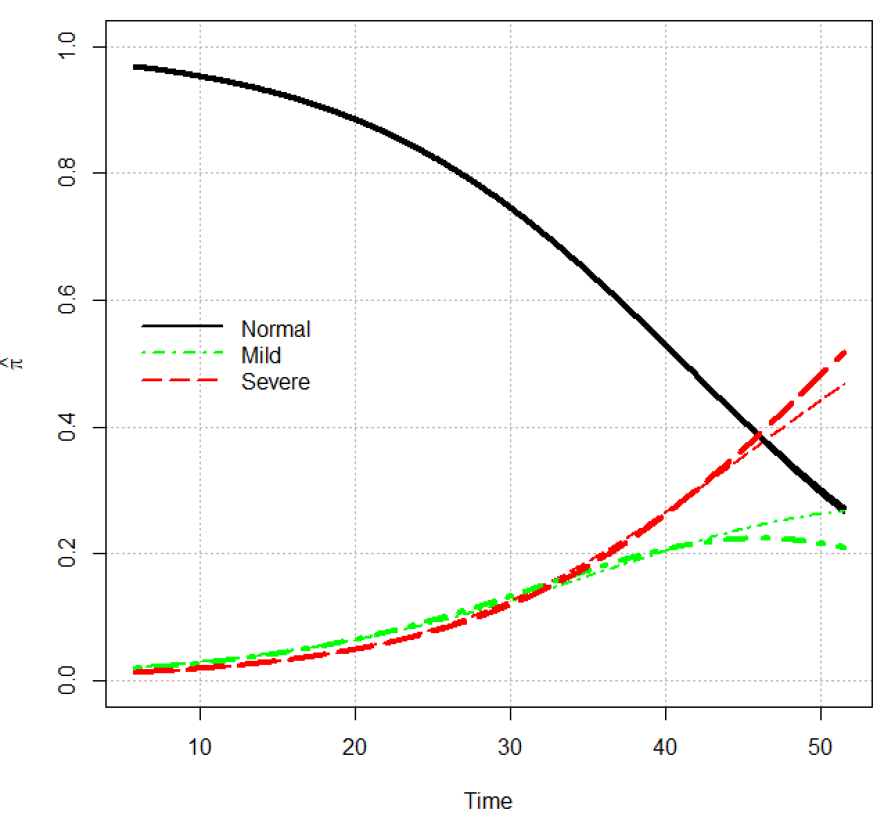

Notice how close the two models are! As exposure time increases, the estimated probability of having a more serious form of pneumoconiosis increases.

Part f) (3 points)

> -mod.fit.ord$coefficients
time
-0.09590405
> exp(-5*mod.fit.ord$coefficients)
time
0.6190803
> exp(5*mod.fit.ord$coefficients) #Invert
time
1.615299

> conf.beta <- confint(object = mod.fit.ord, level = 0.95)
Waiting for profiling to be done...

Re-fitting to get Hessian

> conf.beta
2.5 % 97.5 %
0.07347826 0.12041126

> -conf.beta #For our beta1
2.5 % 97.5 %
-0.07347826 -0.12041126

> exp(-5*conf.beta)
2.5 % 97.5 %
0.6925386 0.5476843

> exp(5*conf.beta)
2.5 % 97.5 %
1.443963 1.825870

With 95% confidence, the odds of a normal instead of a mild or severe response change by 1.44 to 1.83 times when time is decreased by 5 years. The same interpretation holds for normal or mild vs. severe due to the proportional odds.

Alternatively, one could say the odds of a lower severity vs. a higher severity change by 1.44 to 1.83 times when time is decreased by 5 years (with 95% confidence).

- (3 points) Are there any advantages of using one model (multinomial vs. proportional odds) rather the other for the data used in 1) and 2)? Explain.

The proportional odds regression model is best to use. There is only one odds ratio that needs to be interpreted with the proportional odds model because of the ordinality for the response. With the multinomial regression model, there were three odds ratios. We can see from the plot in part 2d) that the estimated probabilities are practically the same for both, so the proportional odds model (because of its simpler structure, smaller number of parameters) is the preferred choice.

Notice that the degrees of freedom for the LRT is only 1 for the proportional odds model, but it was 2 for the multinomial regression model. In terms of critical values, . Thus, in general for these types of problems, it will be easier to reject the null hypothesis and show there is an effect when present (i.e., more power with the proportional odds model).

