**Specific probability distributions for random variables**

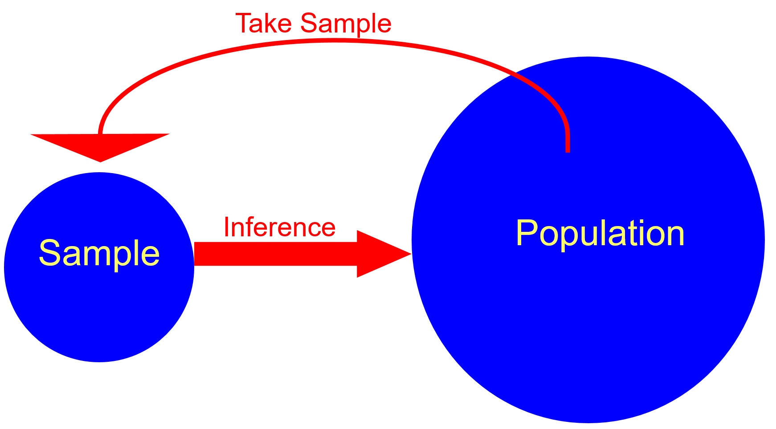

Again, PDFs are population quantities which gives us information about the distribution of items in the population. There are many PDFs that are used to understand probabilities associated with random variables. There are a few PDFs which are used for multiple real-life situations. These PDFs are described next. From this section, it is important to be able to answer the following:

* What are these PDFs that can be used for multiple situations?
* When can these PDFs be used?
* What are the means and variances for random variables characterized by these PDFs?

**Discrete uniform probability distribution**

Suppose Y is a discrete random variable of interest. The simplest PDF for it is when the probability of observing a particular value is equal for all possible values of Y! Because probabilities are the same, this PDF is called the uniform PDF.

If the random variable Y assumes values of y1, y2, …, yk with equal probabilities, then the discrete uniform distribution is given by



Notes:

* y1, y2, …, yk are just a convenient way to iterate out all possible values that Y can take on.
* Because f(y) is dependent on whatever we put in for k, some books may write it as f(y;k).

The mean and variance for the random variable X is

 and 

Why are these the values for E(Y) and Var(Y)?

Remember that μ = E(Y) =  and σ2 = E[(Y-μ)2] = Var(Y) =  in general for discrete random variables. Then

E(Y) = 

and



Example: Roll one die (die.R, die.ipynb)

Let Y = die #1 result. The PDF is



Notice that y1 = 1, …, y6 = 6 and .

Finding the mean and variance produces:



and



> y <- 1:6

> fy <- 1/6

> mu.y <- sum(y*fy)

> var.y <- sum((y-mu.y)^2 * fy)

data.frame(mu.y, var.y)

mu.y var.y

1. 3.5 2.916667

