**Hypothesis tests - One-tail tests**

The hypothesis tests performed so far have been of the form:

Ho:μ = μo vs. Ha:μ ≠ μo

where μo is just a number like 11.6cm.

In order to reject Ho, the test statistic is too big OR too small (i.e. there are two rejection regions). These kinds of hypothesis tests are called two-tail (sided) tests because the rejection region falls in two tails of the probability distribution.

Now we are going to discuss ONE-TAIL (SIDED) Tests:

|  |  |
| --- | --- |
| **Test** | **Name** |
| Ho:μ≥μo  Ha:μ<μo | Left-tail |
| Ho:μ≤μo  Ha:μ>μo | Right-tail |

* To reject Ho for left-tail tests, the test statistic must be < a negative critical value; i.e. on the far left side of the t distribution.
* To reject Ho for right-tail tests, the test statistic must be > a positive critical value; i.e. on the far right side of the t distribution.

1) The Confidence Interval Method - 4 Steps

1. State Ho and Ha
2. Find the “one-sided” CI for μ

|  |  |  |
| --- | --- | --- |
| **Test** | **Name** | **(1-α)100% CI** |
| Ho:μ≥μo  Ha:μ<μo | Left-tail |  |
| Ho:μ≤μo  Ha:μ>μo | Right-tail |  |

For example, suppose the CI for the left-tail test gives an interval such as (-∞,2). Therefore, we have an upper bound on the value of μ. If Ho: μ≥3 and Ha: μ<3, then the CI says that μ is less than 3 and one would reject Ho.

1. Reject or do not reject Ho – Check if the hypothesized value of μ is inside the interval.
2. Conclusion – Describe what 3. means in terms of the original problem

Here’s an easy way to remember if one should use a “+” or “-“ for the confidence interval corresponding to a left- or right-tail test. Suppose again that Ho: μ≥3 and Ha: μ<3, and the CI is now (b, ∞), where b is some number. This interval would correspond to using a “-“ in the equation. Would you ever be able to reject the null hypothesis for some value b?

Example: Tire life (tire_life.R)

A consumer group is concerned about a manufacturer's claim that their tires last on average at least 22,000 miles. A sample of 100 tires are taken and the number of miles each lasted is recorded. The sample mean was 21,819 miles and the sample standard deviation was 1,295 miles. Perform a hypothesis test to see if there is evidence to disprove the manufacturer's claim using a type I error rate of 0.01.

1. Ho: μ≥22,000  
   Ha: μ<22,000

In order to disprove the claim, μ<22,000 needs to be in Ha. Then

α

= P(reject Ho | Ho is true)

= P(sample says μ<22,000 | μ≥22,000)

= 0.01.

Thus, I am controlling the probability of making this type of error!

1. Find the “one-sided” CI for μ

 = 21,819 + 2.364×1,295/

Therefore, the 99% confidence interval is

-∞ < μ < 22,125.14

> ybar <- 21819

> s <- 1295

> alpha <- 0.01

> n <-100

> qt(p = 1 - alpha, df = n-1) #Notice there is no

alpha/2

[1] 2.364606

> upper <- ybar + qt(p = 1 - alpha, df = n-1) * s /

sqrt(n)

> upper

[1] 22125.22

Because a tire will not last negative miles, it would be acceptable to give the lower bound of the interval as 0.

1. Because, μ ≥ 22,000 is in the CI, do not reject Ho.
2. There is not sufficient evidence to disprove the manufacturer’s tire life claim.

2) The Test Statistic Method - 5 Steps

1.State Ho and Ha

2.Find the test statistic

3.Find the critical value

|  |  |  |
| --- | --- | --- |
| **Test** | **Name** | **Critical Value** |
| Ho:o  Ha:<o | Left-tail | -tα, n-1 |
| Ho:o  Ha:>o | Right-tail | +tα, n-1 |

4. Reject or do not reject Ho

Left-tail:

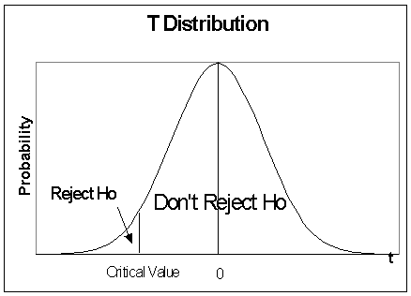

Right-tail:

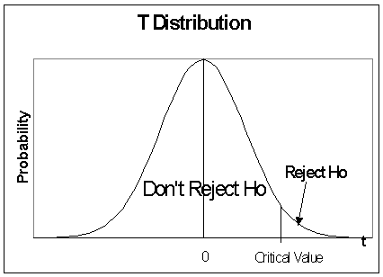

Write reject or don’t reject Ho and provide a reason.

5. Conclusion

Example: Tire life (tire_life.R)

1.Ho:22,000  
Ha:<22,000

2. 

> mu0 <- 22000

> t <- (ybar - mu0) / (s / sqrt(n))

> t

[1] -1.397683

3.-t, n-1  = ‑t0.01, 99 = ‑2.364

4.

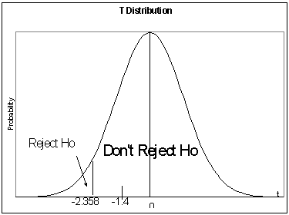



Because ‑1.4 > ‑2.364 don't reject Ho.

1. There is not sufficient evidence to disprove the manufacturer’s tire life claim.

3) The P-value Method - 5 Steps

1.State Ho and Ha

2.Find the p-value

a)Compute test statistic

b)Find the p-value

| **Test** | **Name** | **p-value** |
| --- | --- | --- |
| Ho:o  Ha:<o | Left-tail | P(T<t) |
| Ho:o  Ha:>o | Right-tail | P(T>t) |

**For right-tail (left-tail) tests, this gives the probability of finding a value of t at least this great (small) assuming Ho is true.**

Note: These are one-tail tests, so only the probability for one-tail is needed.

3.State 

4.Reject or do not reject Ho

Reject Ho if p-value <  and do not reject if p-value  

Example of don’t reject for right-tail test:

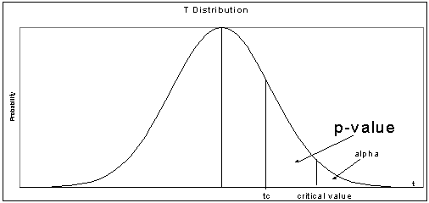



5. Conclusion

Example: Tire life (tire_life.R)

1.Ho:22,000  
Ha:<22,000

2.P(T < ‑1.4) = 0.0823

> pt(q = t, df = n - 1)

[1] 0.08266614

Remember that the p-value is found through integration:

 = 0.0823

3. = 0.01

4.

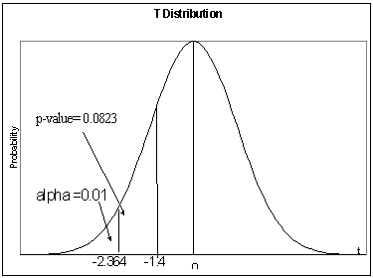

0

Because 0.0823 > 0.01, don't reject Ho.

5.There is not sufficient evidence to disprove the manufacturer’s tire life claim.

Note: P-value interpretation: If μ is really ≥ 22,000 in the population, then a test statistic value, t, no smaller than what this was observed would occur about 8.23% of time if the hypothesis test process (take a new sample and perform a new hypothesis test) is repeated a large number of times. Thus, it may occur about 8 times out of 100. This is borderline with regard to it being a likely event, and it is why the p-value is close to the level of significance, α = 0.01. Often, people (including me!) will say there is “marginal evidence” against Ho.

Example: HIV vaccine

In-class discussion

Example: Volleyball quality control (volleyball.R, volleyball.csv)

Suppose Ho: μ≥11.6 vs. Ha: μ<11.6 is being tested with α=0.05.

> t.test(x = volleyball$radius, alternative = "less", mu =

11.6, conf.level = 0.95)

One Sample t-test

data: volleyball$radius

t = -0.6001, df = 35, p-value = 0.2762

alternative hypothesis: true mean is less than 11.6

95 percent confidence interval:

-Inf 11.78158

sample estimates:

mean of x

11.49999

Notice alternative = "less" in the above code. There is an alternative = "greater" value available for the function as well.

1.Ho: 11.6

Ha: <11.6

2.CI: (-∞, 11.78)

3.Because 11.6 is inside the interval, do not reject Ho.

4.There is not sufficient evidence to indicate that the mean radius is less than 11.6.

See hyp_1sample_pic.xlsx (replace  with  in the image) to see how different values for n, , s, and α can affect the hypothesis test decision.

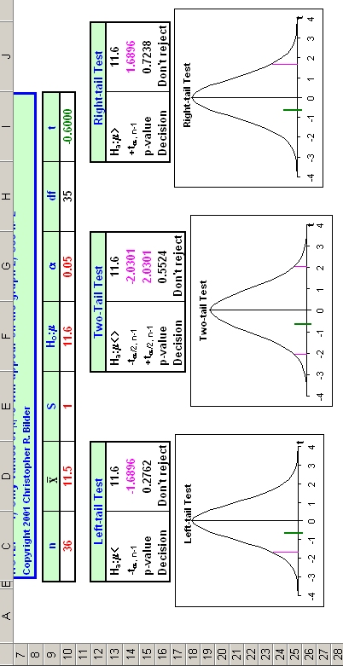

Example: Car warranty (car_warranty.R)

Car companies often use 3-year, 36,000-mile warranties for their new cars. The warranty will cover the engine, transmission, and drive train for all new cars up to 3 years or 36,000 miles, whichever comes first. One dealership believes drivers tend to reach 36,000 miles before 3-years of ownership for a particular type of car. The dealer takes a random sample of 32 owners producing the following statistics on number of miles driven after 3 years:  = 39,900 and s = 1,866.

1. State the Type I and II errors for the hypotheses below.

Ho:  36,000

Ha: > 36,000

Type I: Reject Ho, but Ho is true.

Reject   36,000, but  really is  36,000.

The sample leads you to believe that the average miles driven is greater than 36,000 (i.e., μ ≤ 36,000 is incorrect), but in actuality the average miles driven is less than or equal to 36,000.

Notes:

* The probability of this happening is set at a level of .
* The probability of correctly rejecting Ho is 1-.

Type II: Do not reject Ho, but Ha is really true.

Do not reject   36,000, but  really is > 36,000.

The sample does not give you enough evidence to conclude that the average miles driven is greater than 36,000, but the average miles driven really is greater than 36,000.

Notes:

* The probability of this happening is . This probability is not controlled. Thus, given that  really is > 36,000, the probability of committing this Type II error could be 0, 0.1, 0.2, 0.99, …, or 1.
* The probability of correctly concluding do not reject Ho when Ho is really true is 1-.

Notice how specifying α and not specifying β controls what goes into Ho and Ha!

1. Perform a hypothesis test at the significance level of 0.01 using the test statistic or p-value method.

Test statistic method:

1. Ho: 36,000  
   Ha: >36,000
2. 

> ybar <- 39900

> s <- 1866

> alpha <- 0.01

> n <- 32

> #Test statistic

> mu0 <- 36000

> t <- (ybar - mu0) / (s / sqrt(n))

> t

[1] 11.82301

1. t0.01, 31 = 2.453

> qt(p = 1 - alpha, df = n-1) #Notice there is no alpha/2

[1] 2.452824

1. Because 11.8230 > 2.453, reject Ho.
2. There is sufficient evidence to show that the average miles driven in 3-years is greater than 36,000 miles.

Make sure you can draw a picture of the t distribution for this example!

P-value method:

1. Ho: 36,000   
 Ha: >36,000

2. 

p-value = P(T > 11.8230) = 2.545×10-13

> 1 - pt(q = t, df = n - 1)

[1] 2.544631e-13

P-value interpretation: If μ is really ≤ 36,000 in the population, then a test statistic value, t, at least this large (11.82) would occur 0.0000000002544% of the time if the hypothesis test process (take a new sample and perform a new hypothesis test) is repeated a large number of times. This is VERY, VERY unlikely! Therefore, most likely μ really is NOT ≤ 36,000.

1. =0.01
2. Because 2.545×10-13 < 0.01, reject Ho.
3. There is sufficient evidence to show that the average miles driven in 3-years is greater than 36,000 miles.

CI method: Do on your own!

From a customer’s viewpoint, should they expect to have their car to be under warranty for 3 years? Explain.

No, because the average number of miles driven is greater than 36,000. Thus, their warranty will expire before 3-years of ownership is reached on average.

Notes:

* Students usually say deciding what goes into Ho and Ha is the toughest part of hypothesis testing! The equality part always is in Ho. Also, let the control of a type I error guide you to what goes in Ho or Ha.
* The hypothesis tests done in these notes are often called t-tests because the t distribution is used in the test.

**Summary of hypothesis testing steps**

For the test statistic method:

1. State Ho and Ha
2. Calculate the test statistic
3. State the critical value
4. Decide whether or not to reject Ho
5. State a conclusion in terms of the problem

For the p-value method:

1. State Ho and Ha
2. Calculate the p-value
3. State α
4. Decide whether or not to reject Ho
5. State a conclusion in terms of the problem

For the CI method:

1. State Ho and Ha
2. Calculate the CI
3. Decide whether or not to reject Ho.
4. State a conclusion in terms of the problem